Early Years Childcare Sufficiency Assessment 2025

Contents:
- Overall Assessment and Summary
- Demand for Childcare
- Supply of childcare
- Funded Early Education
- Cost of Childcare
- Quality of childcare in our area
- Parents and carers view of childcare in our area
- Identified Gaps
- Methodology

Overall Childcare Sufficiency Assessment and Summary

Sefton Council is required by law to “report annually to elected members on how they are meeting their duty to secure sufficient childcare and make this report available and accessible to parents.” In this report, we have assessed sufficiency using data about the need for childcare and the amount of childcare available.
We have prepared this report in order to meet this duty. Having sufficient childcare means that families are able to find childcare that meets their child’s learning needs and enables parents to make a real choice about work and training. This applies to all children from birth to age 14, and to children with disabilities. Sufficiency is assessed for different groups, rather than for all children in the local authority. In this report, we have made an assessment of sufficiency using data about the need for childcare and the amount of childcare available, and feedback from local parents about how easy or difficult it has been for them to find suitable childcare. We use information about childcare sufficiency to plan our work supporting the local childcare economy.’
Overall sufficiency in our area:
- Funded early education for 2-year-olds:
Generally sufficient but varies from area to area and capacity is impacted by staffing.
- Universal (15 hour) funded early education for 3- and 4-year-olds:
Sufficient, however not equally distributed.
- Working parent’s (30 hour) funded early education for children from 9 months:
We are at risk of being insufficient for places for children 2 and under,
Staffing concerns may impact places for 2 year olds.
Sufficient for 3- and 4-year places although this is not equally distributed.
- Early years childcare outside the funded entitlements:
We are at risk of being insufficient for places for children 2 and under
Staffing concerns may impact places for 2 year olds
Sufficient for 3- and 4-year places although this is not equally distributed
- Childcare before and after school:
We have sufficient childcare to meet current demand; however, we need to consider future demand in line with the early years expansion and potential increased take up.
- Childcare during the school holidays:
Our evidence suggests that we do not have many Ofsted registered clubs, however we know that there are lots of activity clubs and HAF provision across the borough which parents’ access, but we do not hold this specific data.
- Childcare for children with special educational needs and disabilities (SEND):
Our data suggests that we have sufficient Early Years places, however staffing can be a barrier in some areas and so we will need to carefully monitor this. Wrap Around provision in Wrap around Schools and community venues offer inclusive places, however our local specialist and resourced provision does not currently offer after Wrap Around childcare onsite.
- Childcare during atypical hours (outside 8am to 6pm on weekdays):
We have very limited provision offered outside of typical working hours, however we do not have evidence through enquiry that this is an unmet need.

Since the last assessment 29 places have been created through capital funding for children aged 2 and under with 72 due to be developed by the end of the Autumn term 2025. We have had one successful application through the school-based nursery programme who will offer places for children under 2 years.
We have developed close working partnerships and delivered additional training to students studying towards Early Years and childcare programmes and have engaged with career events and activities with 9 high schools, 3 colleges and Edge Hill University. We have held a targeted Early Years recruitment event and attended 3 events arranged by Sefton@work

2. Demand for Childcare

Population: Children 0-4 living in Sefton by Ward and Sefton total.
The tables below detail the number of children per age group. Take up of the various childcare offers will vary by ward.
Ward Name | Aged: 0 | Aged: 1 | Aged: 2 | Aged: 3 | Aged: 4
Ainsdale | 100 | 93 | 85 | 95 | 87
Birkdale | 100 | 108 | 132 | 113 | 128
Blundellsands | 92 | 86 | 80 | 105 | 95
Cambridge | 76 | 85 | 76 | 94 | 98
Church | 102 | 114 | 105 | 111 | 106
Derby | 162 | 163 | 148 | 173 | 167
Duke's | 77 | 97 | 64 | 95 | 89
Ford | 140 | 112 | 137 | 153 | 145
Harington | 70 | 54 | 91 | 72 | 72
Kew | 153 | 154 | 184 | 158 | 191
Linacre | 192 | 181 | 193 | 216 | 187
Litherland | 160 | 156 | 167 | 176 | 151
Manor | 108 | 109 | 115 | 118 | 114
Meols | 92 | 83 | 97 | 94 | 102
Molyneux | 120 | 118 | 139 | 117 | 113
Netherton and Orrell | 150 | 144 | 164 | 157 | 140
Norwood | 143 | 148 | 160 | 163 | 188
Park | 72 | 94 | 94 | 92 | 99
Ravenmeols | 96 | 106 | 102 | 114 | 116
St Oswald | 92 | 119 | 112 | 104 | 139
Sudell | 145 | 130 | 148 | 158 | 117
Victoria | 140 | 152 | 124 | 167 | 154

Population: Children over 5 years old living in Sefton by Ward and Sefton total

Ward Name | Aged: 5 | Aged: 6 | Aged: 7 | Aged: 8 | Aged: 9 | Aged: 10 | Aged: 11
Ainsdale | 129 | 103 | 145 | 127 | 128 | 137 | 138
Birkdale | 133 | 134 | 139 | 134 | 127 | 158 | 171
Blundellsands | 97 | 125 | 97 | 123 | 116 | 108 | 113
Cambridge | 90 | 80 | 82 | 99 | 100 | 84 | 78
Church | 115 | 133 | 126 | 124 | 115 | 120 | 129
Derby | 156 | 173 | 164 | 184 | 159 | 147 | 144
Duke's | 82 | 90 | 98 | 87 | 89 | 85 | 88
Ford | 179 | 167 | 172 | 165 | 154 | 151 | 162
Harington | 93 | 92 | 104 | 106 | 100 | 124 | 142
Kew | 148 | 196 | 190 | 210 | 197 | 188 | 174
Linacre | 171 | 187 | 165 | 177 | 149 | 162 | 167
Litherland | 167 | 155 | 157 | 178 | 142 | 167 | 183
Manor | 131 | 138 | 122 | 131 | 135 | 134 | 133
Meols | 118 | 121 | 109 | 113 | 132 | 111 | 147
Molyneux | 124 | 123 | 126 | 154 | 127 | 141 | 144
Netherton and Orrell | 150 | 150 | 160 | 180 | 170 | 173 | 177
Norwood | 193 | 184 | 205 | 218 | 218 | 199 | 204
Park | 99 | 128 | 107 | 103 | 119 | 140 | 128
Ravenmeols | 112 | 125 | 136 | 133 | 127 | 124 | 124
St Oswald | 132 | 137 | 143 | 146 | 153 | 143 | 125
Sudell | 134 | 148 | 145 | 134 | 133 | 148 | 125
Victoria | 166 | 165 | 146 | 157 | 150 | 151 | 147

Special Educational Needs and Disabilities (SEND):
Early Years Schools and Settings are required to follow a Graduated Approach to identify the individual support needs for children who have or may have Special Educational Needs. Not all children with identified SEND needs will have an Education Health Care Plan. In Sefton the Early Years SEND team support schools, settings and childminders to ensure inclusive environments and practice for all children. At the time of this assessment there are 713 children known to the Early Years SEND Team.
Number of children with an EHCP:
Age Range | Number of EHCPS
Under 2 | 1
2-4 | 141
Reception year 6 | 1571
Secondary School-Year 7 to 11 | 1477

Changes to Population:
Estimates imply that the Early Years (0-4 years) population is reducing in Sefton, with an overall reduction of 7% from 2013 to 2022, possibly due to reductions in birth rates. Sefton’s crude birth rate (the number of live births per 1,000 mid-year total population estimate) in 2022 was 8.8. This remains below the Liverpool City Region at 9.8 and below the average in England at 10.1. Despite a declining birth rate, additional funded entitlements are likely to increase demand for early Years childcare which in turn may impact demand for Wrap around.

Supply of Childcare

In total there are 186 providers of Early Years childcare providers in our local authority offering a maximum of 881 places for under 2’s 1378 places for 2-year-olds and 3524 places for 3- and 4-year-olds.

Type of Provision | Number of Providers | Number of places for under 2’s | Number of places for 2-year-olds | Number of places for 3- and 4-year-olds.
Childminders* | 73 | 98 | 100 | 100
Nursery classes in schools including Maintained nurseries | 53 | 0 | 242 | 1853
Private, voluntary and independent nurseries | 60 | 783 | 1036 | 1571

*Childminder ratios are worked out differently to PVI and maintained nursery providers, childminders also have to include their own children in rations. For this exercise, it is assumed that a single childminder delivering Early Years funded placements will have capacity for 1 under 2, 1 2–3-year-old and one 3–4-year-old however the offer may differ from childminder.
For private, voluntary and independent nurseries and childminders the registered places represent the maximum capacity per age group as reported by the setting. In practice, some providers choose to operate below the number of registered places. Reasons for this may include the lay out of the room, health and safety reasons, admitting fewer children to meet the needs of the cohort. The most common reason for not operating to full capacity is recruitment and retention challenges.
Children may attend childcare full time or part time. The table above represents the number of places available for children accessing a full-time place, for the hours that the setting is open. In some cases, two or more children may access one place.

Early Years Vacancies per Ward:
Vacancy data was collected in the summer term 2025, this is generally the busiest term as children access funding the term after their eligible age and so intake will be staggered over the year. Autumn vacancies tend to be highest. Most providers give us termly information, but data returns can be a challenge. The table therefore represents ‘known vacancies’
Average Weekly Vacancies
 | All Year Round |  |  | Term Time Only
Ward | Under 2’s | 2 Year Olds | 3 and 4 year olds | Under 2’s | 2 Year Olds | 3 and 4 Year olds
Ainsdale | 3.8 | 4.3 | 9.5 | 0 | 0.8 | 5.1
Birkdale | 0 | 0 | 3.5 | 0 | 1 | 2.2
Blundellsands | 9.6 | 3.6 | 10.9 | 0 | 0 | 4
Cambridge | 0 | 0 | 0 | 0 | 0 | 0
Church | 13.1 | 23 | 13.8 | 0 | 3 | 5
Derby | 7.7 | 7.2 | 3.3 | 0 | 4.1 | 11.7
Dukes | 18.2 | 10 | 12.8 | 0 | 0 | 0
Ford | 6.8 | 7.1 | 13.7 | 0 | 0 | 38.5
Harington | 5.6 | 9.3 | 21.7 | 0 | 0 | 18.3
Kew | 3.1 | 7.9 | 14.4 | 0 | 0 | 2.9
Linacre | 0 | 0 | 0 | 0 | 0 | 11.5
Litherland | 0 | 0.2 | 0 | 0 | 0 | 11.9
Manor | 0 | 0 | 0 | 0 | 7.4 | 4.2
Meols | 0.2 | 0 | 0 | 0 | 3.4 | 12.2
Molyneux | 0 | 0 | 0 | 0 | 2 | 26.5
Netherton and Orrell | 3 | 1.4 | 1 | 0 | 2.4 | 22.7
Norwood | 1.8 | 3.6 | 7.4 | 0 | 0.7 | 1
Park | 1.3 | 4.5 | 5 | 0 | 0 | 9.9
Ravenmeols | 1.8 | 2.7 | 0.4 | 0 | 0 | 3.8
St Oswalds | 4.5 | 15.8 | 11.6 | 0 | 0.5 | 12.8
Sudell | 0.2 | 0.2 | 0 | 0 | 0 | 8.1
Victoria | 7.5 | 12.2 | 5.2 | 0 | 0 | 0
Sefton Total | 88.2 | 113 | 134.2 | 0 | 25.3 | 212.3

Early Years a typical hours:

Type of Provision | Number of providers | Available before 8am weekdays | Available after 6pm weekdays | Available weekends
Childminders | 73 | 17 | 3 | 0
Nursery classes in schools including Maintained nurseries | 53 | 8 | 0 | 0
Private, voluntary and independent nurseries | 60 | 28 | 2 | 0

Holiday Clubs:
Type of Provision | Number of Providers | Number of Registered Places
School run | 2 | 100
PVI on school site | 5 | 319
PVI in a community setting | 6 | 261

Tracking the supply of childcare for school aged children is challenging as not all provision is Ofsted registered. Parents may use provision that is not registered ‘childcare’ such as extra-curricular activities before or after school and holiday activity clubs such as sports camps.

Funded Early Years Childcare

Some children are entitled to government funded childcare. These entitlements cover 38 weeks per year at 30 hours per week. Many providers will offer a stretched model of delivery which means that parents and carers can access all year-round childcare but for less hours per week. All funded entitlements can be accessed the term after the child becomes eligible.
- All children aged 3 and 4 years are entitled to 15 hours per week until they start reception class.
- Children from 9 months old where a lone parent or both parents work over 16 hours and earn under £100,000 are entitled to 30 hours until they start reception class.
- Children aged two whose families are in receipt of certain benefits (including families claiming low income in work benefits) may be entitled to 15 hours per week.
Parents and carers do not have to use all of their funded entitlement. They may choose to split them between providers.
Take up of Early Years Entitlements:
Early Years childcare is not statutory and take up will depend on individual circumstances. Although we know how many children access entitlements, we do not carry data on families who may be entitled to a place but choose not to access this.
We can make an estimated calculation on the % uptake of 2-year funding for children eligible for additional government support (sometimes called the 2 year offer.) At the time of this report this stands at 58%. This is significantly lower than previous years and is a trend that is also reported anecdotally by neighbouring Local Authorities. We have not had enquiries from parents or professionals that suggest families are unable to find a place, however this is something that we need to monitor. A likely explanation is that some families could be eligible for both this entitlement and the working parent code. Local Authorities are directed by the DfE to ensure that these families are recorded as being eligible for both and therefore we will carry out an exercise after settings complete their headcount to assess the number of families impacted.

5. The Cost of Childcare

Parents and carers should be able to access their entitlement free of charge however government funding does not usually cover the costs of meals and consumables such as nappies, wipes and sun creams. Most settings will provide meals and snacks and some consumables at an additional charge with alternatives offered to families who may prefer to provide their own. Some families may need to access additional paid for hours to meet their childcare needs.

Providers set their own charges for hours accessed by families which are outside the government funded hours. Families may also be entitled to support through tax free childcare and universal credit childcare in addition to funded hours. This table provides the average charges per provider type. The types of providers cannot always be compared however, as childcare as providers use different models of delivery offering flexibility of service which is variable across the sector. There may be variations on price based on the number of hours a family uses, with reductions for longer hours or reductions for family groups, some providers charge more for younger children as the staff to child ratio is higher and therefore more expensive. Providers decide their own charges.

Average charges for non-funded hours in PVI settings
Early Years Provider Survey 2025

Daily | Half Day* | Hourly*
£57.05 | £33.17 | £8.77

Average charges for non-funded hours in maintained/ school nurseries

Daily | Half Day* | Hourly*
£35.10 | £17.20 | £5.80

Average charges for non-funded hours with a childminder:
Source: Childminder Survey 2025
Daily | Half Day* | Hourly*
£48.70 | £28.20 | £5.70

Average wrap around childcare costs:

Breakfast Club | After school club | Holiday club (full day)
£3.84 | £10.78 | £25.50
* Not all settings will offer half day sessions or the option of hourly childcare.

Quality of Childcare

All childcare providers must register with and be inspected by Ofsted, who will give them an overall grade for the quality of their provision. Childminders and private and voluntary providers are included on the Early Years register and schools and standalone maintained nursery schools are included on the schools’ register. The grades for both registers are equivalent. Schools with nurseries have an overall inspection grade for the whole school.
Schools and Early Years providers have four possible Ofsted grades:
Outstanding  Good | Requires improvement.  Inadequate
Some providers are awaiting their first full inspection. These have been excluded from the percentage calculation.
Ofsted ratings for Sefton childcare provision. Source: Ofsted and Sefton Early Years data.

Type of provision | Percentage Good/ Outstanding/ Met
Childminders registered with Ofsted | 100%
Childminders registered with an agency | 100%
Maintained and school nursery | 100%
Private, voluntary, and independent nurseries, including term time only. | 100%
Out of School Clubs registered with Ofsted | 100%

**Ofsted registered Out of school provision receive a judgement of met or not met. There are Out of school provisions that have not yet been inspected, they have not been included when calculating the percentage of provisions that have ‘met’ standards.
Out of school provision run by a school share their inspection grading with the school.
Early Years Quality Protocol process:
In addition to the inspection judgement the local Authority have a support package in place for settings. All settings are eligible for Quality Improvement visits which may result in a universal, targeted, or intense level of support. Where safeguarding concerns are identified the Local Authority Quality Team are duty bound to report to Ofsted and to follow Local Authority Safeguarding procedures.
The Early Years Team provide a programme of training events and projects to raise quality as well as individual casework for children with SEND and support for settings to develop inclusive practice and environments.

- Parents and carers view of childcare in our area
Early Years Childcare:
Parent and carers were surveyed on their experiences of accessing Early years Childcare. Here is a summary of the responses:
How easy is it to afford Early Years Childcare?
Option | Total | Percent
Very easy | 3 | 2.48%
Fairly easy | 25 | 20.66%
Fairly difficult | 24 | 19.83%
Very difficult | 28 | 23.14%
Not applicable | 9 | 7.44%
Not Answered | 32 | 26.45%

How far do you agree/disagree with this statement?

I am happy with the childcare session times I have been offered:
Option | Total | Percent
Strongly Agree | 22 | 18.18%
Agree | 50 | 41.32%
Disagree | 10 | 8.26%
Strongly Disagree | 2 | 1.65%
Don't Know | 1 | 0.83%
Not Applicable | 4 | 3.31%
Not Answered | 32 | 26.45%

Childcare providers are in the right location:
Option | Total | Percent
Strongly Agree | 23 | 19.01%
Agree | 52 | 42.98%
Disagree | 9 | 7.44%
Strongly Disagree | 1 | 0.83%
Don’t Know | 4 | 3.31%
Not Answered | 32 | 26.45%

I am happy with the quality of the childcare:

Option | Total | Percent
Strongly Agree | 39 | 32.23%
Agree | 42 | 34.71%
Disagree | 3 | 2.48%
Strongly Disagree | 0 | 0.00%
Don’t Know | 5 | 4.13%
Not Answered | 32 | 26.45%

Wrap Around Childcare:
Parent and carers were surveyed on their experiences of accessing Wrap Around Childcare. Here is a summary of the responses:

How easy is it to find childcare for your school aged child(ren)?
Option | Total | Percent
Very Easy | 24 | 16.22%
Fairly Easy | 32 | 21.62%
Neither Easy nor difficult | 24 | 16.22%
Fairly Difficult | 24 | 16.22%
Very Difficult | 20 | 13.51%
Not Answered | 24 | 16.22%

How far do you agree/disagree with this statement?
Sessions are available at the times I need:
Option | Total | Percent
Strongly Agree | 37 | 25.00%
Agree | 39 | 26.35%
Disagree | 22 | 14.86%
Strongly Disagree | 16 | 10.81%
Don’t Know | 10 | 6.76%
Not Answered | 24 | 16.22%

Wrap Around childcare providers are in the right location:
Option | Total | Percent
Strongly Agree | 44 | 29.73%
Agree | 49 | 33.11%
Disagree | 8 | 5.41%
Strongly Disagree | 6 | 4.05%
Don’t Know | 17 | 11.49%
Not Answered | 24 | 16.22%

I am happy with the quality of the childcare:
Option | Total | Percent
Strongly Agree | 48 | 32.43%
Agree | 45 | 30.41%
Disagree | 9 | 6.08%
Strongly Disagree | 8 | 5.41%
Don’t Know | 14 | 9.46%
Not Answered | 24 | 16.22%

Family Information Service Enquiries:
Surveys identify that most parents and carers look to word of mouth with just 5% saying that they would contact the service for advice. We have supported families this year following a closure of a nursery in Derby Ward. We have also had reports of challenges accessing childcare in Maghull, particularly Sudell ward. This year we have had an increase of enquiries regarding charges and delivery models of funded entitlements. We are working with providers to audit provision to ensure this is compatible with the statutory guidance.







8.Identified Gaps and threats to sufficiency:
There are limited choices available for atypical hours of childcare (outside 8am to 6pm on weekdays and weekends). The Early Years funding team provide broker service to support to parents who might encounter difficulty in finding a suitable place.

Early Years

In general, there are sufficient places for 3- and 4-year-olds across Sefton. In terms of risk to sufficiency, (in particular in line with the new funded entitlements, the new funded entitlements,) the maps below demonstrate areas across the borough that has low (red), medium (amber) and high sufficiency (green) in relation to places for children in each age group. These maps where developed using data based on the take up of funded entitlements in each ward compared to the supply of places available in each age group.

Under 2’s | 2-year-olds | 3- and 4-year-olds
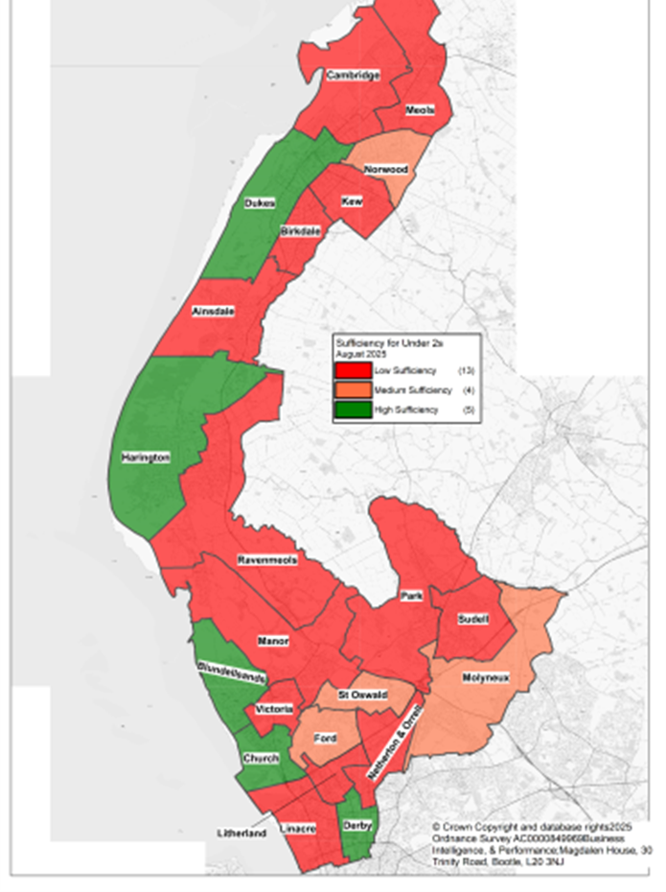 | 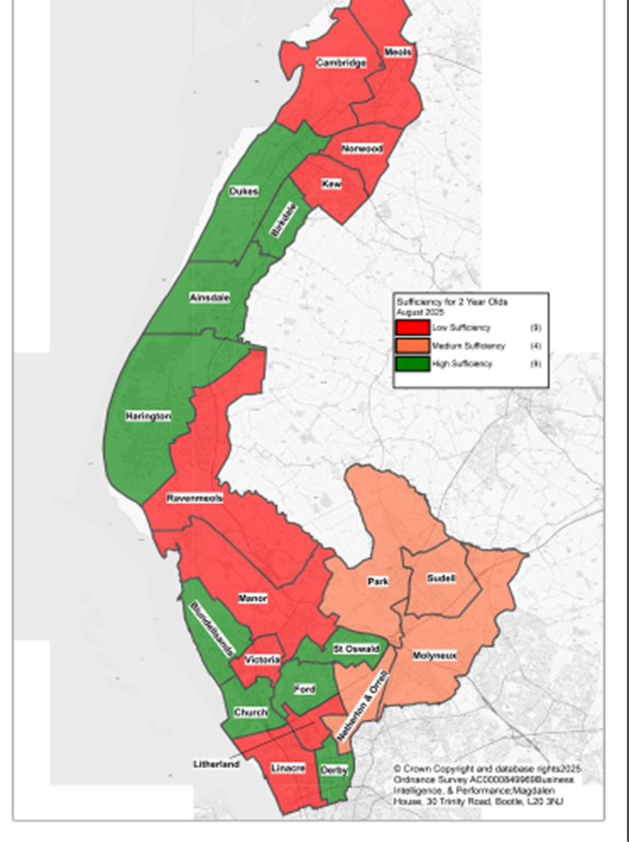 | 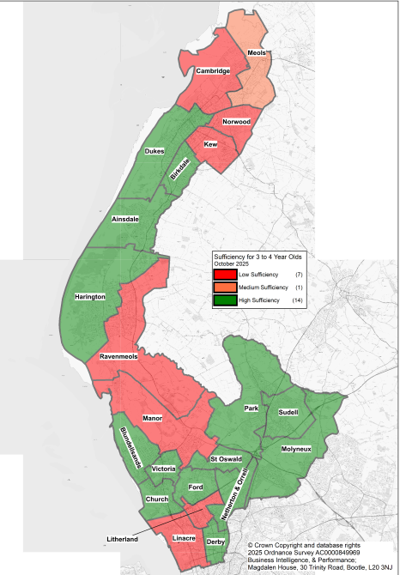

Wrap Around Childcare:
- There are 74 primary schools in Sefton.
- All schools in Sefton have access to before school childcare either on school site provided by school of PVI provider or off-site community venue.
- 47 schools have access to a ‘full wrap around’ offer (starting from 8am or before and until 6pm or later.)
- 18 schools have an equivalent offer (from 8 am or earlier until at least 5:30pm)
- 9 have a partial offer (offer provision before and after school provision but afterschool club finishes before 5:30pm)
Through the National Wrap Around programme, we have been able to offer financial support to start up or expand provision for before and after school childcare. There are a small number of provisions who cannot meet demand for wrap around childcare, these settings will be supported as part of the programme.
Recruitment and Retention:
The biggest threat to sufficient childcare across all age groups is the recruitment and retention of qualified staff and in particular practitioners with a level 3 full and relevant Early Years qualification. This is required to meet required ratios as set out in statutory guidance including in before and after school childcare attended by children attending nursery.





9. Methodology
We have used the following data to compile this assessment:
- Number of children based on Nomis Labour Market datasets.
- Children with EHC plans based on SEND Local Authority Tables
- Supply of childcare: based on data provided by Ofsted, who regulate early years provision in schools and childcare provision. This has been supplemented with local knowledge.
- Take up and demand local authority payment data from summer term 2025
- Capacity and vacancy rates: Based on provider surveys undertaken during In the summer term 2025
- Funded early education: data on take up of funded early education entitlements is based on the Early Years and Schools Censuses, which are taken every January and published by the Department of Education in the statistical collection.
- Data on entitlement to a funded early education place for 2-year-olds is provided by the Department for Work and Pensions.
- Price of Childcare: Based on information collected from provider surveys undertaken in Spring term 2025
- Quality of childcare: data on childcare quality is provided by Ofsted Data
This assessment was published in September 2025

Further Information
Kim Evans-Early Years Partnership and Project Coordinator
Email: kimberley.evans@sefton.gov.uk

