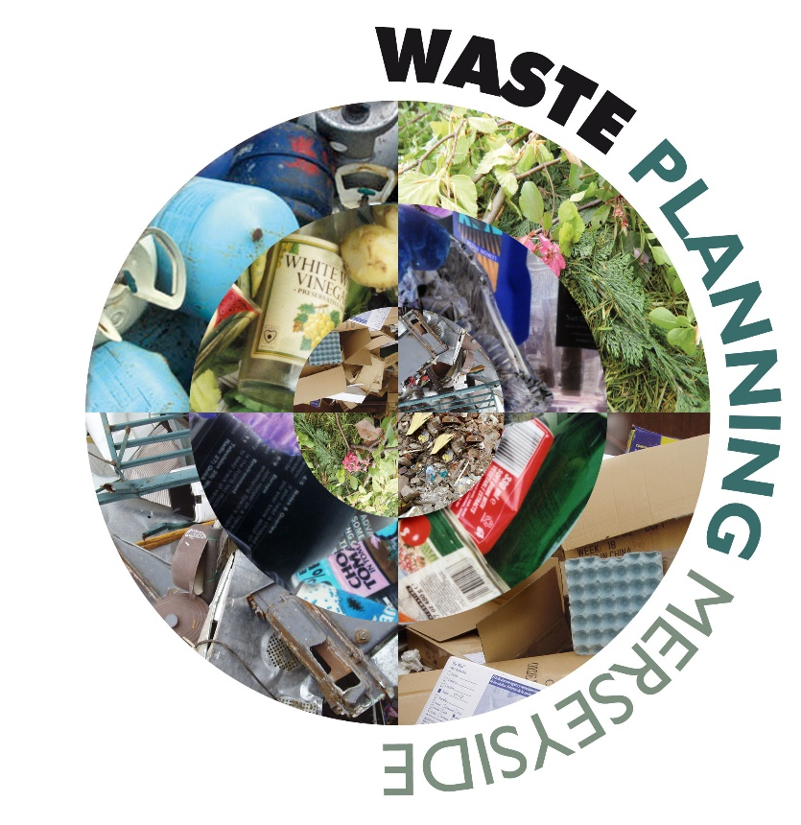

Review of the Merseyside and Halton Joint Waste Local Plan
Paper 3: Spatial Strategy and Sites Review
June 2025



Review of Vision, Strategic Objectives, Spatial Strategy and Sites

Waste Local Plan Vision:
- The Waste Local Plan Vision states:
The Waste Local Plan Vision: By 2027, the Waste Local Plan will have facilitated the development of a network of sustainable and modern waste management facilities which serve the needs of the local communities of Merseyside and Halton, enabling them to be as sustainable and self sufficient as possible in terms of waste management.
The communities of Merseyside and Halton will have taken responsibility for their waste, and through effective resource management, created economic prosperity by transforming waste into a resource and moving waste up the Waste Hierarchy.
This network of facilities will be designed and sited to avoid negative impact on health and amenity and enhance the natural and built environment, with site allocations being appropriate to the scale and type of waste management facility, and where possible enable waste management in Merseyside and Halton to support mitigation and adaptation to climate change.
- To help enable this vision, a series of eight Strategic Objectives were set, as follows:
Strategic Objectives
SO1 - To plan for sufficient waste management facilities to meet Merseyside and Halton's identified waste management needs.
SO2 - To promote waste minimisation and optimise re-use and recycling of waste materials for both waste specific and non-waste planning applications.
SO3 - To encourage waste management facilities which increase re-use, recycling and value/energy recovery of all waste types, including through the use of new, effective and safe waste management technologies where appropriate, and minimise final disposal, in order to meet national targets and Merseyside and Halton's local waste targets.
SO4 - For Merseyside and Halton, as one of the North West's City Regions, to be a leader in promoting transformation of waste to resource to encourage social, economic, environmental and employment gain from sustainable waste management.
SO5 - To raise awareness in sustainable waste management amongst the people and business communities of Merseyside and Halton to reduce waste arisings and increase recycling rates, in particular given the low starting point for the sub-region in terms of recycling.
SO6 - To minimise the adverse effects of waste management development (including transportation) and enhance positive impacts where possible, on human health, local amenity and the natural and urban environment and heritage of Merseyside and Halton.
SO7 - To promote high quality development for waste management facilities.
SO8 - For all new waste management facilities on Merseyside and Halton to take account of and contribute to reductions in greenhouse gas emissions and mitigate the effects of climate change.
- The strategic objectives are taken into account when considering applications for planning applications for both waste and non waste uses. The WLP development management policies help aid this process. For non waste uses, particularly for major development, policies WM8 (Waste Prevent and Resource Management) and WM9 (Sustainable Waste Management Design and Layout for New Development) are applied. These are policies that can help influence waste reduction measures by wider industry and the general public and are likely to continue to be used going forward.

- The waste hierarchy diagram below shows that the vast majority of applications for waste management uses have been for recycling and re-processing facilities and energy from waste uses. The two disposal applications have actually been in relation to restoration of former landfill sites to improve environmental outcomes.
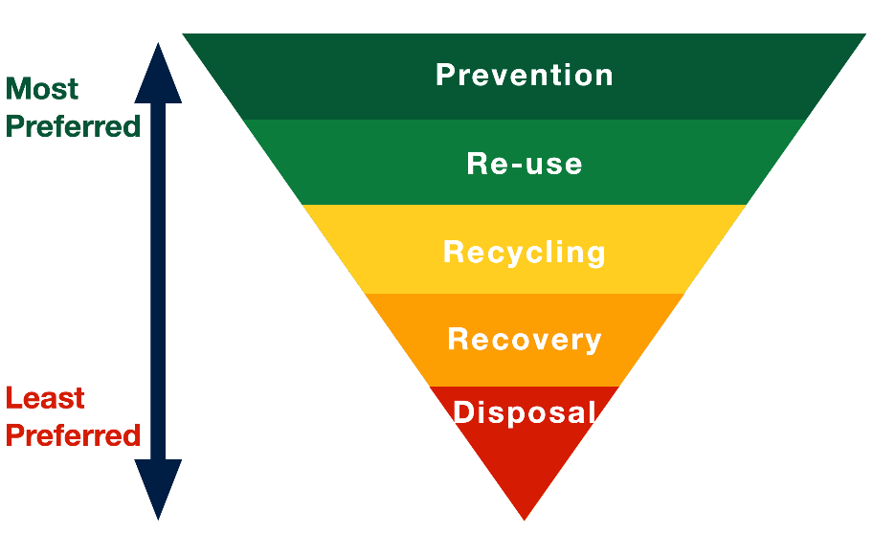

0
7
25

15

2

- Overall, it is considered that the Vision and Strategic Objectives have been met, however, some of objectives have been more successful than others. SO1 and SO2 have been met. SO3 has largely been successful with most waste planning applications pushing waste up the waste hierarchy as shown above.

- The updated AMR shows that strategic objectives SO4 and SO5 have been less successful, with recycling rates for Local Authority Collected Waste (LACW) decreasing over the plan period. However, there may be a number of factors contributing to this including the pandemic. However, commercial and industrial waste recycling figures are significantly better and increasing.

- SO7 has been met, generally the new waste management facilities coming forward have demonstrated improved environmental measures and consideration of amenity impacts, although very few have met BREEAM or equivalent standards. Quite a few applications during the plan period have been for improvements to existing facilities.
- It is likely that strategic objective SO8 has been realised, however, the indicators proposed to record this have been hard to get data on, and therefore, measurement has been difficult. Most applications have related to improved recycling and re-processing activity within the LCR, which in turn should reduce greenhouse gas emissions. The Climate Emergency and legislative changes including Simpler Recycling should help move all of these objectives forward and enable easier monitoring going forward.
Spatial Strategy
- The Spatial Strategy for the Waste Local Plan is based on a sub-regional site approach identifying a sub-regional size facility in each of the authority areas. Taking account of proximity to waste arisings and infrastructure. District sites are identified to accommodate smaller scale local facilities. Areas around these existing clusters of waste management facilities have been identified as Areas of Search. Finally, two inert landfill sites were identified, but there were very limited opportunities for the location of these. The sub-regional site approach was adopted on the basis that a combined pattern of diffuse, clustered and centralised sites would be the best spatial option for the Waste LP. It provides a wide range of site sizes and requirements, takes account of clustering of sites, maximising potential benefits that can be gained from co-locating waste management facilities, and the situation on the ground in terms of spatial pattern of employment land uses such as business parks.
Table 1: Availability of Allocated Sites in the Waste Local Plan
Key: Green (available); Blue (potential capacity increase available at existing waste management facility); Grey (unavailable); Orange (inert landfill)
District | Site Ref | Site Name | District-level /Sub-regional site | Site Area (ha) | Status
Halton | H1 | Site at Widnes Waterfront, Widnes | Sub-regional | 7.8 | Available – previous planning permission expired.
Halton | H2 | Eco-cycle Waste Ltd, 3 Johnsons Lane, Widnes | District-level | 2 | Unavailable – waste facility closed. Other use on site.
Knowsley | K1 | Butler’s Farm, Kirkby Industrial Estate | Sub-regional | 8 | Unavailable – however capacity has been provided at another site. K1being marketed for distribution/logistics.
Knowsley | K2 | Image Business Park, Acornfield Road, Knowsley Industrial Park | District-level | 2.8 | Unavailable –Other use on site.
Knowsley | K3 | Mainsway Ltd, Ellis Ashton Street, Huyton Business Park | District-level | 2.3 | Available – operational waste transfer station with capacity for expansion.
Knowsley | K4 | Former Pilkington Glass Works, Ellis Ashton Street, 1.3 Huyton Business Park | District-level | 1.3 | Unavailable – Other use on site.
Knowsley | K5 | Cronton Claypit, Dacres Bridge Lane | Inert Landfill |  | Operational – approximately 6 years capacity remaining
Liverpool | L1 | Land off Stalbridge Road, Garston | Sub-regional | 5.4 | Available – previous planning permission expired.
Liverpool | L2 | Site off Regent Road / Bankfield Street | District-level | 1.4 | Available
Liverpool | L3 | Waste Treatment Plant, Lower Bank View | District-level | 0.7 | Available – operational hazardous waste facility with capacity for expansion.
St Helens | S1a | Former Transco Site, Pocket Nook | Sub-regional | 4.5 | Available – operational waste transfer station with capacity for expansion.
St Helens | S2 | Land North of T.A.C., Abbotsfield Industrial Estate | District-level | 1.3 | Available
St Helens | S3 | Bold Heath Quarry, St Helens | Inert Landfill |  | Both quarrying and infill activity ongoing. Remaining void space approx. 600,000m³.
Sefton | F1 | Alexandra Dock 1, Metal Recycling Facility | Sub-regional | 9.8 | Available – operational metal recycling facility. Permission for EfW to serve site expired.
Sefton | F2 | 55 Crowland Street, Southport | District-level | 3.6 | Available – operational waste transfer station with capacity for expansion. Planning permission for Anaerobic Digestion Facility and improvements to existing WTS.
Sefton | F3 | Site North of Farriers Way, Sefton | District-level | 1.7 | Unavailable – planning permission for logistics/distribution warehouse. Could potentially still be used for waste purposes.
Sefton | F4 | 1-2 Acorn Way, Bootle | District-level | 0.8 | Partially available – part of site used for tarmac/recycled aggregate processing.
Wirral | W1 | Car Parking /Storage Area, former Cammell Laird Shipyard, Campbeltown Road | Sub-regional | 5.9 | Unavailable – permission granted for temporary open air storage on majority of site and industrial unit on part of site.
Wirral | W2 | Bidston MRF / HWRC, Wallasey Bridge Road | District-level | 3.7 | Available – operational waste management facility (HWRC/MRF/WTS)
Wirral | W3 | Former Goods Yard, Adjacent Bidston MRF / HWRC, Wallasey Bridge Road | District-level | 2.8 | Available – operational waste transfer station with capacity for expansion.

- Table 1 shows the current availability of the allocated sites, four out of 6 sub-regional sites are still available. Two of these are sites are occupied by existing waste operators and therefore, access to these sites is dependent on the operator’s cooperation or business need to amend/increase operations. Eight of the twelve district level sites remain available. Six of these were included as there was potential to increase capacity and improve the existing waste facility. Therefore, availability of these 6 sites depends on the current operator.

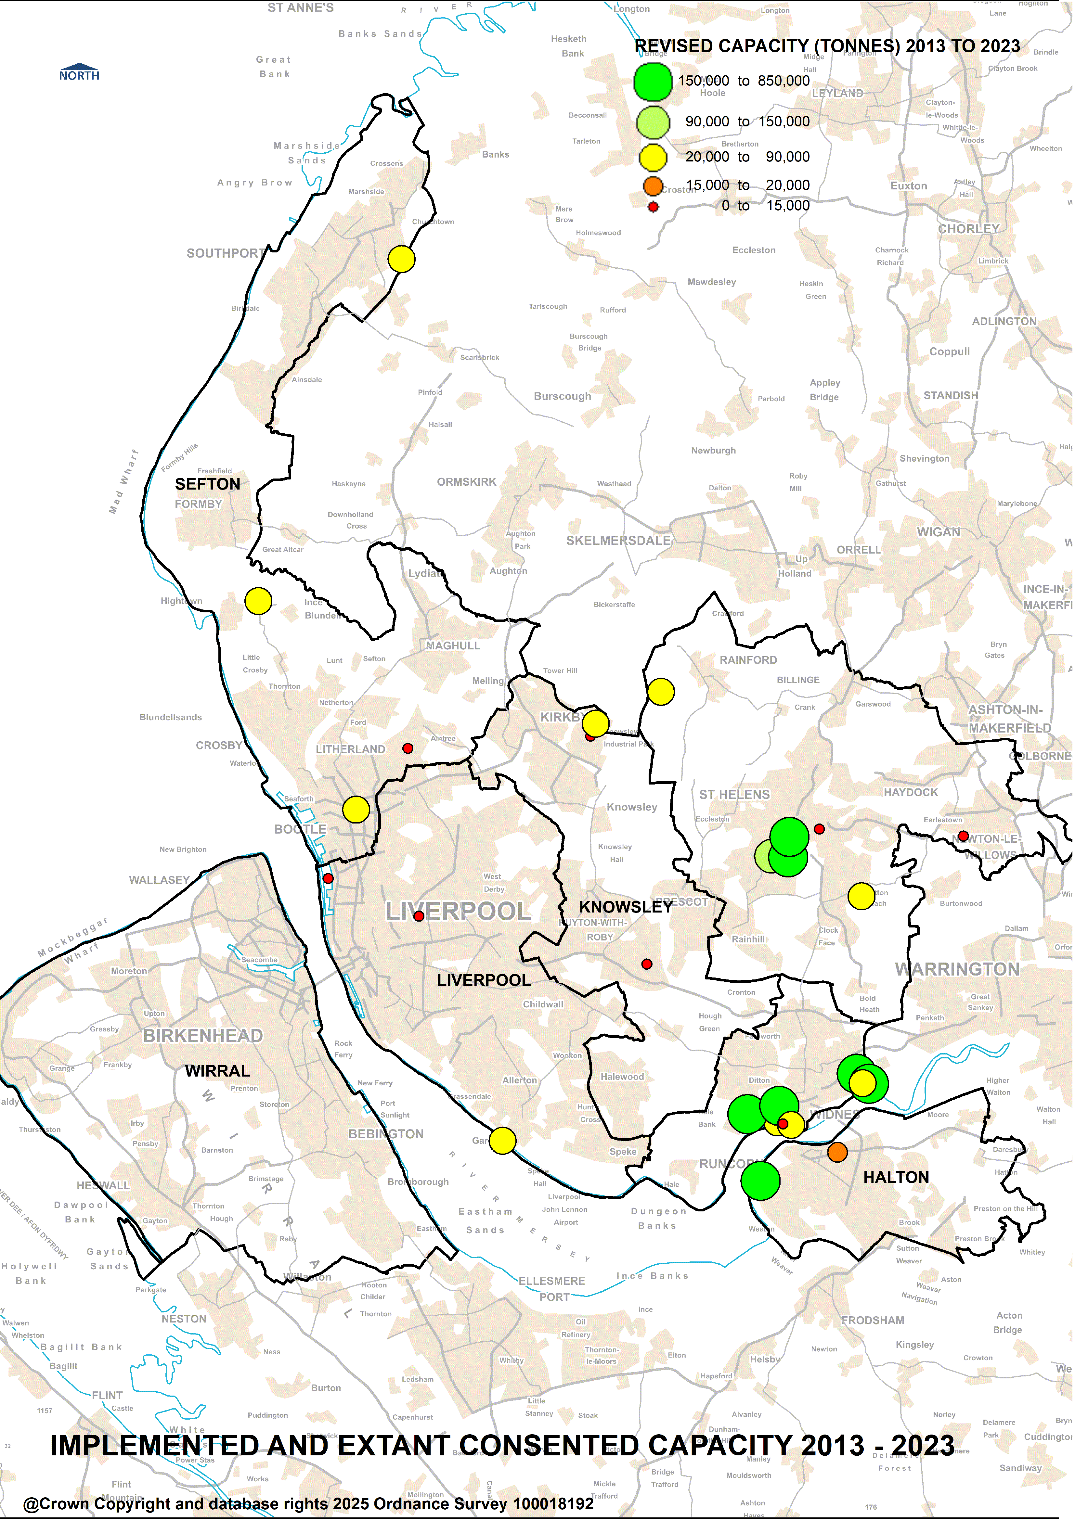
- Since the adoption of the WLP, the waste applications that have come forward during the first 10 years of the plan period, have been unevenly distributed and mainly focused in three districts, as illustrated spatially in Figure 1. This is partly due to a large facility in Halton increasing capacity. Also, a large facility for managing incinerator bottom ash needing to be located close to the Runcorn Energy from Waste facility to avoid increased traffic movements.

Figure 1: Implemented and Extant Consented Waste Management Capacity since 2013
- It’s also important to note that the vast majority of new waste capacity has come forward on unallocated sites or has been provided as an increased capacity at an existing waste management facility. However, overall the facilities have probably met a combination of diffuse, centralised and clustered sites, perhaps with the most focus on improvements to existing facilities.
Table 2. Number of New Sites, Capacity and % Total Capacity of Waste Management Facilities per District since Adoption of the Joint Waste Local Plan.
Apr 2013 – Mar 2023
District | Consented capacity (tonnes per annum) |  | No. of sites | % of Total Capacity
Halton | Total consented | 1,422,400 | 16 | 54.3
Halton | Extant or implemented | 1,337,500 | 15 | 62
Knowsley | Total consented | 188,000 | 9 | 7.1
Knowsley | Extant or implemented | 68,000 | 6 | 3.1
Liverpool | Total consented | 81,312 | 5 | 3.1
Liverpool | Extant or implemented | 81,312 | 5 | 3.8
Sefton | Total consented | 376,000 | 4 | 14.4
Sefton | Extant or implemented | 191,000 | 4 | 8.9
St Helens | Total consented | 502,872 | 9 | 19.2
St Helens | Extant or implemented | 477,872 | 8 | 22.1
Wirral | Total consented | 48,200 | 3 | 1.8
Wirral | Extant or implemented | 0 | 0 | 0
Total | Total consented | 2,618,784 | 46 | 99.9
Total | Extant or implemented | 2,155,684 | 38 | 99.9

- Table 2 shows that since the adoption of the Plan in July 2013, almost 54.3% of total new consented capacity has come forward in Halton. Followed by St Helens (19.2%) and Sefton (14%), amounting to almost 88%. However, not all of these permissions have been implemented and some have lapsed or been superseded by an alternative proposal at the same site. The second row shown for each district is the actual capacity that has been implemented or has an extant permission at the time of writing. Taking account of extant and implemented permissions only, this shows an even greater percentage of capacity falls in Halton (62%) followed by St Helens (22.1%) and Sefton (8.9%). This is likely to be a consequence of the locations of existing industry and other waste management facilities, land value and also accessibility of the major road and rail network. Therefore, most of the new waste capacity is focused on central and eastern districts of the Plan Area. Full details of all planning applications, consents and their status are shown in Appendix 1.

- To give a more complete picture, during the preparation period of the WLP, a significant number of new waste management facilities came forward, some were speculative and many have been implemented, and others were included as consented capacity within the WLP some of which have since been implemented. Of these pre-adoption applications, those that were consented, implemented and still operational are shown in Figure 2. This demonstrates that all constituent districts have played a role in facilitating new waste management capacity, albeit the majority is confined to certain districts.

- Therefore, it seems reasonable to conclude that overall, the spatial strategy has worked, albeit, that the majority of new consented facilities are not on allocated sites. Likewise, some districts, Halton in particular has received and consented the greatest amount of new capacity.

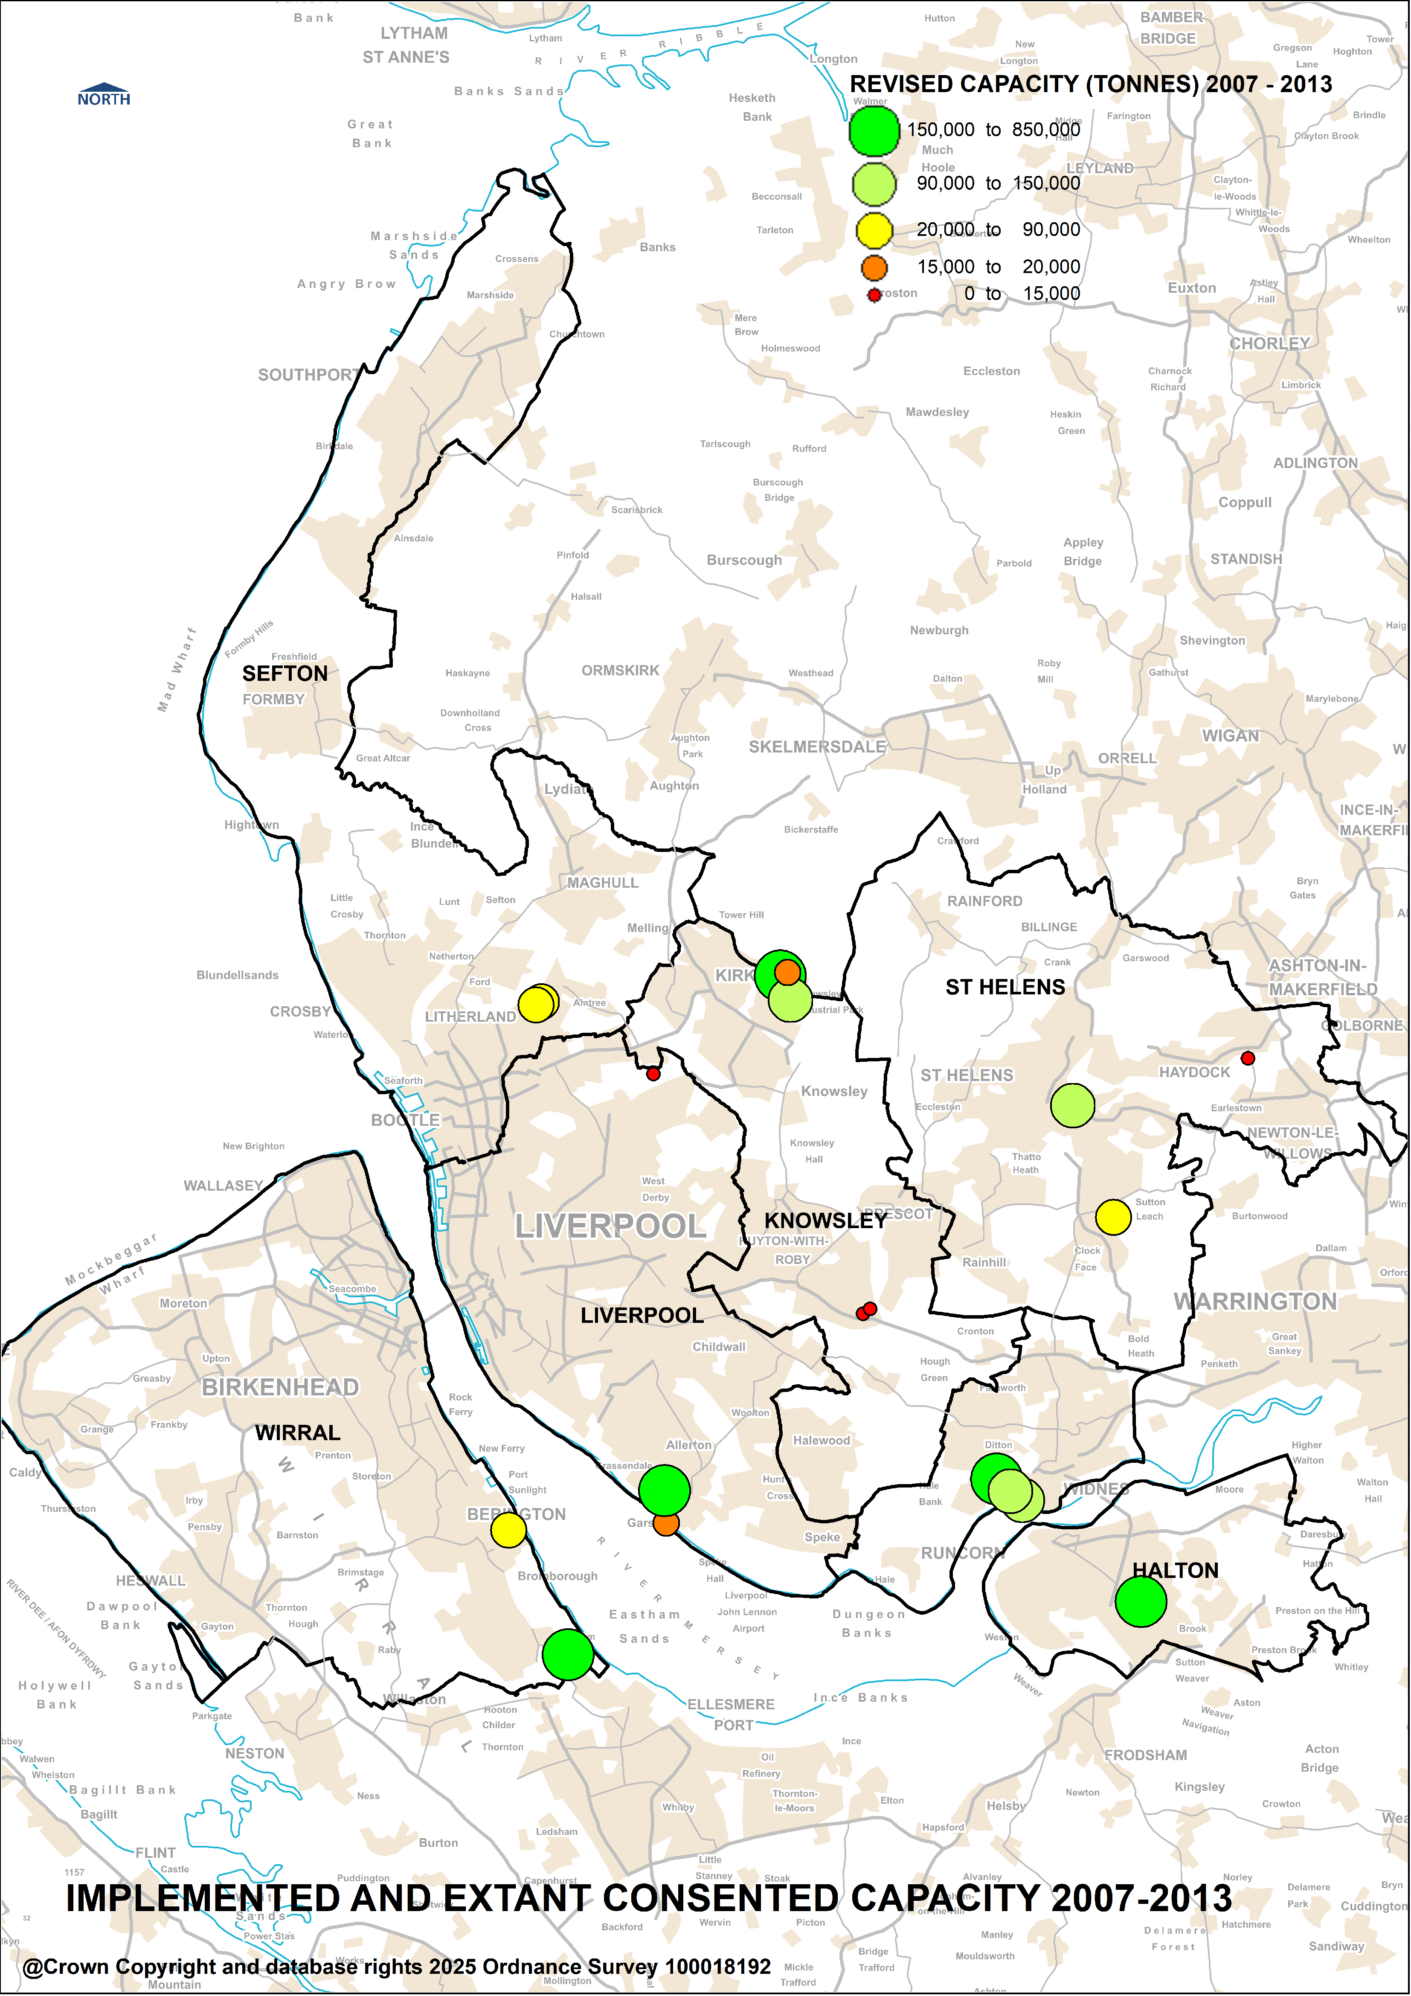
Figure 2: Implemented and Extant Consented Waste Management Capacity 2007 - 2013

- The WLP was based on the July 2011 needs assessment, which in addition to the capacity already granted by permissions at the end of 2010, also determined that there was a requirement for the following additional facilities.
Contingency Requirements
Type of Facility | Size/capacity tpa | Number | Met by:
Materials Recycling Facility (contingency as capacity requirements only just met by Gillmoss coming on line) | 100,000 | 1
HWRC | 15,000 | 1 | Old Swan HWRC, Cheadle Avenue (was included in NA2011 figures)
Anaerobic digestion/IVC (for food waste) | 50,000 | 4 | 1-2 met by Refood, Widnes (90ktpa)  3-4 potentially met by permission on allocation F4 (80ktpa) (not yet implemented)
Waste transfer station (for managing residual LACW and rail transfer (sub-regional site size) | Approx. 450,000 | 1 | Met by Kirkby Rail Waste Transfer Station (466.5ktpa)  (replaces requirement for K1)
Primary/pre-treatment of residual non hazardous waste | 150,000 | 2 | Met by permission at H1 and L1 at time of adoption, however, permissions now lapsed. (350ktpa including 50ktpa IVC for food waste)  Potentially met by increased capacity (250ktpa) at WSR Recycling, Widnes
Specialised C&I waste facility (for non LACW type waste) | unspecified | 1 | Potentially met by IBA recycling facility, Widnes (250ktpa)
Hazardous waste treatment | unspecified | 1 | Increased capacity at:  Mulberry Waste Ltd (3ktpa);  SCRL Ltd (50ktpa); and  Veolia Garston. (56ktpa)
Other compensation (for self sufficiency to compensate for 450,000 tpa residual waste being exported) | 200,000 | 2 | Potentially met by increased capacity at Runcorn EfW which manages 983,680 tpa of which only 4,441 arises in Merseyside (250ktpa increased capacity)
Total | 1,465,000 | 13 | 1,495,500 (not including sites H1 & L1)

- By taking into account, how the contingency requirements have been met, it can be seen that the majority of the 10 sites that have contributed to the requirements, 8 were existing or planned for facilities at the time of adoption of the WLP.

Net Self Sufficiency
- Whilst acknowledging that waste movements do not respective administrative boundaries, all waste planning areas should aim to ensure that they are net self-sufficient in waste, i.e. they are managing an equivalent tonnage overall when compared to the amount produced and exported. It is also worth noting that at the start of the Plan Period, Merseyside and Halton were net exporters of waste and were aiming towards being net self sufficient in waste management. As can be seen from Table 3, this remained the case for the first 6 years of the plan, albeit slowly the net movements changed from being negative (more waste exported) to positive (more waste imported) in 2019, with a significant shift in movement. This reversal of movements means that Merseyside and Halton are net importers of waste and consequently more than net self-sufficient in waste.

Table 3: Overall WLP Area Net Self-sufficiency (thousand tonnes)
Waste Stream | 2012 | 2013 | 2014 | 2015 | 2016 | 2017 | 2018 | 2019 | 2022
All waste streams (LACW, C&I, CD&E, Hazardous) exported (removed) | 1395 | 1434 | 1964 | 2322 | 2515 | 3571 | 3428 | 2191 | 2067
All waste streams (LACW, C&I, CD&E, Hazardous) imported (received) | 1373 | 1578 | 1584 | 2097 | 2300 | 3245 | 3358 | 3840 | 4321
Net movements (imports – exports) | -22 | +144 | -380 | -225 | -215 | -326 | -70 | +1649 | +2254
Includes non codeable Merseyside figures from WDI

- Interestingly, when imports and exports are shown for each district and broken down into individual waste streams, as shown in Table 4. it is easier to see where the big imports arrive, and which waste streams show the biggest movements. So, for example, although there has not been a huge increase in consented capacity within Sefton, the facilities within this district are already contributing significantly to the overall waste management capacity within the Plan Area. This is likely to be a consequence of the Port.
Table 4: Imports and Exports within each District (Waste Data Interrogator 2022)
Import - Exports | CD&E | HIC | Hazardous | Total
Halton | 257,060.21 | 1,343,519.43 | -11,837.96 | 1,588,741.68
Knowsley | 196,831.38 | 469,003.12 | 33,778.65 | 699,613.15
Liverpool | -319,999.58 | 519,818.90 | 59,748.72 | 259,568.04
Sefton | 72,534.97 | 1,170,986.45 | 55,389.59 | 1,298,911.01
St Helens | 89,716.34 | 13,296.14 | 8,598.35 | 111,610.83
Wirral | -4,641.13 | -29,335.92 | 9,231.93 | -24,745.12
*Data includes movements within the LCR (Halton into Liverpool, Sefton into Wirral etc)

Conclusion
- Overall, it is considered that the spatial strategy has worked with all districts playing a role in providing capacity during the development and implementation of the WLP. However, Halton has by far delivered the greatest consented capacity since the adoption of the WLP, primarily a result of a few very large sites.

- A considerable amount of new capacity has come forward during the plan period to date. This includes significant new capacity at existing waste management sites as well as new facilities, largely on unallocated sites. There are sufficient allocated sites remaining for the duration of the plan period.

- In terms of net self sufficiency, the WLP area has become a significant net importer of waste since the adoption of the Plan, again, this is likely to be a consequence of a number of large sites. However, some districts already played a significant role in waste management due to facilities located on the Port.

Appendix 1: Details of Planning Applications for Waste Management Facilities and their current status during preparation of and since adoption of the Joint waste Local Plan.
Planning ref | Facility type | Address | Capacity (tonnes per annum) | District | Waste Hierarchy position | *Development status | Site type
Apr 2008 to Mar 2013
12/00156/FULEIA | Anaerobic Digestion | Desoto Road, Widnes WA8 0PB | 90,000 | Halton | Other Recovery | Operational | Pre-dates WLP adoption
12/00387/FUL | Inert and non-inert WTS / MRF | WSR, Ditton Road, Widnes | 210,000 | Halton | Recycling | Permission granted. Implemented | Pre-dates WLP adoption
12/00458/FULEIA | Wood-fuelled Biomass Combined Heat and Power Plant | Off Foundry Lane, Ditton, Widnes WA8 0PE | 147,000 | Halton | Other Recovery | Operational | Pre-dates WLP adoption
10/00446/EIA | Mechanical Biological Treatment & In-Vessel Composting | Widnes Waterfront, Moss Bank Road, Widnes, Merseyside WA8 0WN. | 200,000 | Halton | Preparing for reuse/ Recycling | * Permission lapsed? | Allocated site
08/00344/FULEIA | Single stream fluidized bed combustor to produce renewable energy | Granox Ltd, Desoto Road, Widnes, Cheshire, WA8 0PB | ? | Halton | Other Recovery | Operational | Extension to operational facility
07/00068/ELC** | Energy from waste with CHP | Ineos Chlor, South Parade, Runcorn, WA7 4JE | 850,000 | Halton | Other Recovery | Operational | Pre-dates WLP adoption
12/00669/COU | MBT + SRF production and health care waste WTS | Stretton Way, Huyton Business Park | 130,000 | Knowsley | Recycling | Demonstrator – no longer operational | Pre-dates WLP adoption
11/00415/FUL | Waste Transfer station (bulking and rail transfer) | Knowsley Rail Freight Terminal, North Perimeter Road, Kirkby, Merseyside L33 7UZ | 466,500 | Knowsley | Recycling | Operational | Alternative to sub-regional allocated site
11/00221/FUL | Chemical treatment of hazardous. waste and reprocessing of non-hazardous waste | Image Business Park, Acornfield Road, Knowsley Industrial Park, Kirkby, Merseyside L33 7UF | 123,000 | Knowsley | Preparing for Reuse/ Recycling | Permission granted | Existing site
11/00067/COU (08/00247/FUL) | Recycling and Recovery Facility for C&I and construction waste | B I C C, Rod Rollers, Carr Lane, Prescot | 49,000 | Knowsley | Recycling/ Other Recovery | Facility not built out for this purpose. Now burnt down | Pre-dates WLP adoption
10/00153/FUL | Household Waste Recycling Centre | Civic Amenity Site, Wilson Road, Huyton, Merseyside L36 6AD | 5,000 (15*) | Knowsley | Recycling | Operational (12/00551/COU approved for 20,000te trade waste as well as household.) | Pre-dates WLP adoption
10/00691/FUL | Hazardous Waste Transfer Station | The Tank House, Carr Lane, Prescot, Merseyside L34 1NZ | 69,000 | Knowsley | Preparing for Reuse/ Recycling | Was operational now burnt down | Pre-dates WLP adoption
09/00376/FUL | Household Waste Recycling Centre | Land Between Depot Road & North Perimeter Road Knowsley Industrial Park Kirkby | 15,000* | Knowsley | Recycling | Operational | Pre-dates WLP adoption
09/00409/FUL | Autoclaving Facility, application for increase in capacity (50kpta-120ktpa) | Stretton Way, Huyton Business Park | 120,000 | Knowsley | Preparing for Reuse/ Recycling | Demonstrator – no longer operational | Pre-dates WLP adoption
08/00474/FUL | Gasification with CHP | Penrhyn Road/Villiers Road, Knowsley Business Park | 96,000 | Knowsley | Other Recovery | Permission granted but Not built out | Consented capacity included in WLP, not allocated.
11F/1273 | Gasification with CHP | King Street, Liverpool L19 8EG | 15,000 | Liverpool | Other Recovery | Granted - operational | Pre-dates WLP adoption
09F/1012 | Resource Recovery Park (Autoclaving) | Dock Road, Garston Dock, Liverpool L19 | 150,000 | Liverpool | Preparing for Reuse/ Recycling | Permission lapsed | Pre-dates WLP adoption  Allocated site
08F/3196 | Materials Recycling Facility | Stonebridge Lane, Gillmoss Industrial Estate | 100,000 | Liverpool | Recycling | Operational | Pre-dates WLP adoption
S/2011/0377 | Non-inert WTS (green waste only) | Leckwith Road, Netherton, Merseyside L30 6UQ | 20,000 | Sefton | Recycling | Implemented | Pre-dates WLP adoption
S/2011/0561 | C&I WTS | Heysham Road (former Build Center site), Netherton, Merseyside L30 6YJ | 30,000 | Sefton | Recycling | Permission granted. Now operational | Pre-dates WLP adoption
S/2011/0739 | Inert WTS | Heysham Road (former T E C Site), Netherton, Merseyside L30 6TU | 20,000 | Sefton | Recycling | Permission granted but superseded by DC/2016/00639. | Pre-dates WLP adoption
S/2009/0640 | Gasification EfW generating plant (non-CHP) | Alexandra Branch Dock 1, Bootle, Merseyside L20 1ED | 137,500 | Sefton | Other Recovery | Permission lapsed | Proposed extension to operational facility
P/2012/0156 | Non-inert, non-hazardous landfill | Lyme & Wood Pits Landfill Site, Vista Road, Haydock, Merseyside | 202,500 | St.Helens | Disposal | Granted | Site now closed
P/2010/1062 | Drumming operation, hazardous substances consent | Linkway Distribution Park, St.Helens | 100 | St.Helens | Disposal | Permission granted. Now a housing allocation in LP and has been implemented. No waste operation ongoing. | Pre-dates WLP adoption
P/2009/0840 | Clinical and Healthcare Waste Transfer Station | Units 1 & 2, Abbotsfield Road, Reginald Industrial Estate | 5,000 | St.Helens | Recycling | *Granted. Implementation Status unknown (Intercare) | Pre-dates WLP adoption
P/2009/0727 | Waste Transfer Station with Aggregates Recycling Facility | Land to rear of Silverdale House, Abbotsfield Road, Reginald Industrial Estate | 75,000 | St.Helens | Recycling | Granted - operational | Pre-dates WLP adoption
P/2008/0225 | Materials Recycling Facility | Former Transco Site, Pocket Nook Street | 90,000 | St.Helens | Recycling | Now operational facility | Allocated site
APP/12/00595 | Aggregates recycling facility | Commercial Road, Bromborough, Wirral CH62 3NL | 100,000* | Wirral | Recycling | Permission granted. Implemented but operations now ceased. | Site now closed
APP/10/00890 | Open windrow composting | Station Road, Storeton, Wirral CH61 1DG | 20,000 | Wirral | Recycling | Permission granted. Not implemented. Lapsed | Unallocated
APP/09/05766 | Waste Transfer Station | Land North of McTay Boatyard, Magazine Lane, Bromborough, Wirral, CH62 3NJ | 25,000 | Wirral | Recycling | Permission granted | Site now closed.
APP/2008/6316 | Gasification with Autoclaving | North Road, Eastham, Wirral, CH65 1AJ | 400,000 | Wirral | Other Recovery | Permission granted | Capacity included in WLP but not allocated (now operational at lower capacity)
Annual Total ( excluding *) 3,815,600
Jul 2013 to Mar 2014
13/00274/FUL | Wood Storage & Waste Wood Processing | West Bank dock Site, Riverside, Widnes, WA8 OPE | 75,000 | Halton | Preparing for re-use/ recycling | Permitted - operational | Unallocated (Area of Search)
13/00384/FUL | Healthcare Waste Treatment and Transfer facility | Vacant Warehouse, Bradman Road | 22,000 | Knowsley | Recycling | Permission granted - operational | Unallocated (Area of Search)
13/00434/FUL | WEEE recycling facility | Unit 1, 2 And 3, The Lombard Centre, Link Road, Huyton, L36 6AP | 10,000* | Knowsley | Recycling | Permission granted – continuation of use as WEEE (Restart recycling Ltd) | Existing operational facility
13/00781/COU | Vehicle Breakers (ELV) Facility | Eclipse Glass The Ashcroft Centre Ashcroft Road Knowsley Industrial Park Kirkby Knowsley L33 7TW | 5,000 | Knowsley | Preparing for re-use/ recycling | Permission granted. Google Maps 2023 show that operation has started. | Unallocated (Area of Search)
14/00586/FUL | Scrap Yard | 90 Arbour Lane, Kirkby | 1,000 | Knowsley | Preparing for re-use/recycling | Permission granted.  Now operational | Unallocated (Area of Search)
14F/0203 | Household Waste Recycling Centre | Old Swan Recycling Centre, Off Cheadle Avenue, Liverpool 13 | 15,000 | Liverpool | Recycling | Permission Granted. Now operational | Unallocated
P/2013/0325 | Redeveloped Household Waste Recycling Centre | Burtonhead Rd HWRC, St.Helens | 15,000* | St.Helens | Recycling | Redevelopment of existing facility. Operational | Existing operational facility
P/2013/0569 | Autothermophillic Aerobic Digestion (ATAD) | Unit O, Mossbank Industrial Estate, Dairy Farm Rd, Rainford | 25,000 | St.Helens | Other Recovery | Permission granted Possibly implemented, however no operation ongoing on site and unlikely to be extant. | Unallocated
Annual Total ( excluding *) 143,000
Apr 2014 to Mar 2015
14/00613/FUL | Incinerator Bottom Ash Recycling Facility | Land Bounded By Dismantled Railway And South Of Johnsons Lane Widnes | 250,000.00 | Halton | Preparing for re-use/ recycling | Now operational | Unallocated (Area of Search)
15/00060/FUL | Solar Farm and Restoration of Former Landfill | Former Johnsons Lane Landfill, Johnsons Lane Widnes | 166,000.00 | Halton | Re-use | Permission Granted.  Partially completed. | Unallocated (former landfill in Area of Search
14/00481/FUL | Physio-chemical Treatment | Image Business Park, Acornfield Road, Kirkby Industrial Estate | 130,000 | Knowsley | Preparing for re-use/recycling | Permission granted.  Operational | Existing operational facility
P/2014/0399 | Change of use to an end of life vehicle salvage business, the storage of scrap cars and part worn tyre sales | 18 Jackson Street, St.Helens, WA9 1AN | 1,872.00 | St.Helens | Preparing for re-use/ recycling | Permission granted. Appears to be operational (Atlas Salvage but not shown on WDI) | Unallocated
P/2014/0778 | Waste plant for treatment of portable toilet waste | Universal Tanker Solutions Ltd, Neill Road, Bold Industrial Park, St Helens | 25,000 | St. Helens | Other recovery | Permission Granted
APP/14/00805 | Erection of vehicle repair unit, forming an office from re-cycled container units, construction of concrete crushing plant | Wheatland Lane, Seacombe, CH44 7EJ | 12,200.00 | Wirral | Recycling | Permission granted. Implemented but no longer operational. Site now used as Highways depot. | Unallocated
APP/14/00314 | Energy from Waste Facility using gasification technology | Eastham Refinery, North Road, Eastham | 400,000* | Wirral | Recovery | Permission granted (alternative to earlier permission APP/2008/6316)  Now operational | Consented capacity in adopted plan.
Annual Total (excluding *) 419,072 (+166,000 inert restoration materials)
Apr 2015 to Mar 2016
15/00256/FUL | Anaerobic Digestion (extension) | Refood UK Ltd, Desoto Road, Multi Modal Gateway, Widnes | 20,000.00 | Halton | Other Recovery | Extension of capacity to site granted permission pre-adoption. | Extension of operational facility
15/00332/FUL | Inert landraise (followed by installation of solar scheme) | Land bounded by dismantled railway and situated to the south of Johnsons Lane, Widnes | 189,600.00 | Halton (total tonnage landraise) | Disposal | *Granted? Not sure if it went ahead – looks like some earthworks on google maps but not complete. | Former landfill restoration
15/00180/FUL | Landfill restoration | Hedco Closed Landfill Site, Desoto Road, West Bank Estate, | 32,800.00 | Halton (total tonnage restoration materials) | Disposal | Permission granted – implemented. | Former landfill restoration
15/00506/FUL | Inert Waste Recycling Facility | 3 Webber Road, Knowsley Industrial Park, Kirkby | 50,000.00 | Knowsley | Recycling | Permission granted. Contact made with Knowsley Council by Lessee states permission 19/00624/FUL will not be implemented | Unallocated site (Area of Search)
14/00657/FUL | Anaerobic Digestion | Land at Butlers Farm, North Perimeter Road, Knowsley Industrial Park | 70,000.00 | Knowsley | Other Recovery | Whole site gone to market under B1/B2/B8 use including this area of site. Permission won’t be implemented. | Allocated site
15/00509/FUL | Physio-chemical Treatment | Image Business Park, Acornfield Road, Kirkby Industrial Estate | 0 | Knowsley | Preparing for re-use/recycling | Permission granted.  Operational | Existing operational facility
15F/2399 | Biomass boiler (small scale – exempt) | Panorama Kitchens , 11 Belmont Road, Liverpool, L6 5BG | 312.00 | Liverpool | Other Recovery | Permission granted. Implemented | Unallocated
P/2015/0322 | Recycling Centre | Land Adjacent and 8a Reginald Rd Industrial Park, Brindley Rd, St Helens | 35,000.00 | St.Helens | Recycling | Permission Granted (Go Green Recycling Ltd), now operational | Unallocated (Area of Search)
P/2015/0494 | Biomass facility | Starbank Site, Junction Lane, Newton le Willows | 1,000.00 | St.Helens | Other Recovery | * Permission granted. Implementation status Unknown | Unallocated
P/2016/0027/WASTE | Healthcare and Hazardous Waste Treatment Facility | 2-3 Withens Way, Haydock | 24,999 | St Helens | Other recovery | Permission Granted.  Now Operational | Unallocated
P/2015/0601/FUL | Plastic Reprocessing | Hunt Brothers Ltd, Junction Lane, Sankey Valley Industrial Estate, Earlestown | 5,000 | St Helens | Preparing for Re-use/recycling | Permission Granted. Now operational | Unallocated.
APP/15/00553 | Anaerobic Digestion | Riverside House, East Street, Seacombe | 36,000.00 | Wirral | Other Recovery | Permission granted. Not implemented. Expired. | Unallocated
Annual Total 242,311 (+ 56,400 tonnes inert restoration materials)
Apr 2016 to Mar 2017
16/00124/FULEIA | Waste Transfer Station | WSR Recycling Ltd Ditton Road Widnes | 100,000.00 | Halton | Recycling | Permission granted. Fully implemented WDI data showing 259,238 received in 2022. Permit now for 300,000tpa | Extension to existing facility
16/00158/COU | Processing and storage of wood facility | Land To The North West Of Junction Between Ditton Brook And Stewards Brook, Foundry Lane, Widnes | 150,000.00 | Halton | Other Recovery | Permission granted. Implemented | Unallocated but associated with existing facility (Area of Search)
17/00094/FUL | Processing of animal by-products | Secanim, Desoto Road, Widnes | 0 | Halton | Other recovery | Improvements to existing facility. Permission Granted.  Now implemented | Existing Operational Facility
DC/2016/00534 | Waste transfer station, AD facility and biomass boiler | 55 Crowland Street, Southport | 185,000.00 | Sefton | Recycling and Other Recovery | Permission granted. Superceded by DC/2021/02723 | Allocated site
DC/2016/00639 | Salt depot with recycling area | Land Corner Of Heysham Road/Leckwith Road Netherton | 1,000.00 | Sefton | Recycling | Permission granted. Operational | Unallocated site
P/2016/0440/FUL | Ancillary Development to Waste Transfer Station | Biffa, Navigation Road, Pocket Nook, St Helens | 0 | St Helens | Recycling | Ancillary Development, Permission Granted. | Allocated site
P/2016/0628/FUL | Glass processing facility | Knauf Insulation, Ravenhead Road | 120,000.00 | St.Helens | Preparing for reuse | Permission granted. Now operational | Unallocated site
P/2016/0804/FUL | Energy recovery facility with CHP | Greengate Works Sherdley Road | 150,000.00 | St.Helens | Other Recovery | Permission granted. Superceded by P/2018/0675/WEIA | Unallocated site
Annual Total 706,000
Apr 2017 to Mar 2018
17/00435/WST | Extension to Waste Transfer/Recycling Facility and 0.99MW biomass | GSH Recycling, Pickerings Road, Widnes | 0 | Halton | Recycling and other recovery | Permission Granted | Existing Operational Facility
17/00278/FUL | Biomass waste wood boiler | Dams Furniture Ltd | Unspecified | Knowsley | Other Recovery | Permission granted. 20/00549/ful states extension to facility opened in October 2018, so permission implemented. | Unallocated (Area of Search)
DC/2017/00727 | Variation of conditions relating to proposed AD Facility (DC/2016/00534) | 55 Crowland Street, Southport | 0 | Sefton | Recycling & other recovery | Permission granted. Superceded by DC/2021/02723 | Existing operational facility
DC/2017/01328 | Bio-sludge liming treatment | Land Adjacent Orrell Hill Wood | 20,000.00 | Sefton | Recycling | Change of ownership and extension of operational facility | Existing operational facility
DC/2017/01327 | Open windrow composting | Land Adjacent Orrell Hill Wood | 40,000.00 | Sefton | Recycling | Change of ownership and extension of operational facility | Existing operational facility
DC/2017/02198 | Change of use for storage of road planings | 491 Hawthorne Road, Bootle | 10,000.00 | Sefton | Recycling | Refused | Unallocated site (area of search)
P/2017/0779/S73 | Open windrow composting | Mossborough Hall Farm | 20,000.00 | St.Helens | Recycling | Permission granted | Existing operational facility
P/2017/0419/S73 | Variation of condition 1 attached to planning permission P/2014/0511 to allow for the importation of soils for restoration of the site up to 31 December 2018 | Lyme & Wood Pit Tip, Vista Road, Haydock | 0 | St Helens | Landfill Restoration | Permission Granted.  Landfill restoration now complete | Existing Operational Facility (now closed)
Annual Total 80000
Apr 2018 to Mar 2019
18/00285/WST | Waste Transfer and Treatment Facility | Former J Bryan (Victoria) Ltd Site Pickerings Rd Widnes Cheshire WA8 8XW | 85,000.00 | Halton | Recycling | Granted permission in January 2019, however, this was quashed by a JR. Appeal following redetermination also quashed. | Unallocated site
18/00417/S73 | Energy from Waste facility – variation of condition to increase amount of fuel delivered by road | Runcorn Energy From Waste Facility Barlow Way Off Picow Farm Road Runcorn Cheshire WA7 4HG | 250,000.00 | Halton | Other Recovery | Consented. Operational facility. Implemented in full | Existing facility
18/00567/FULEIA | WSR Recycling Ltd Ditton Road Widnes Cheshire WA8 0PA | WSR Recycling Ltd Ditton Road Widnes Cheshire WA8 0PA | 450,000 (from 300000) | Halton | Recycling | Consented (23 May 2019). Operational facility. Permission implemented through pre-commencement conditions however, increase in capacity has yet to be implemented. WSR has confirmed it is the intention to implement in next 24 mths. | Existing facility in Area of Search
19/00008/FUL | Proposed extension to the raw material reception building | Secanim Desoto Road Widnes WA8 0PD | 0.00 | Halton | Other Recovery | *Consented. Operational facility. Status of extension unknown | Existing facility in Area of Search
18/00509/FUL | Proposed extension to accommodate new boiler | Secanim Desoto Road Widnes WA8 0PD | 0.00 | Halton | Other Recovery | *Consented. Operational facility. Status of extension unknown | Existing facility in Area of Search
18/00553/FUL | Extension to existing waste metal facility | Jaguar Plant North Road Halewood Knowsley L24 9LE | 0.00 | Knowsley | Recycling | Consented. Operational facility. 19/00545/ful revised this application. 22/00458/ful for another part of the site shows 19/00545/ful not implemented | Existing inhouse facility
18F/1405 | Recovery and recycling building | Barrys Skips Redfern Street Liverpool L20 8JB | 0.00 | Liverpool | Recycling | Consented. Operational facility. Implemented | Existing facility in Area of Search
18F/3064 | To use existing metal waste transfer facility as a metal waste transfer and processing facility | Stalbridge Docks Dock Road Liverpool L19 2JW | 70,000.00 | Liverpool | Recycling | Withdrawn. | Existing facility
DC/2019/00229 | Open-windrow composting | Hightown Recycling, Orrell Hill Lane, Ince Blundell | 0.00 | Sefton | Recycling | Consented. Expansion of operational facility. This has been implemented | Existing facility
P/2018/0221/FUL | CHP micro generation plant | Palletland Limited, Burtonhead Road | 0.00 | St.Helens | Other Recovery | *Consented. Implementation status unknown | Unallocated site
P/2018/0675/WEIA | Energy from Waste facility | Greengate Works, Sherdley Road | 150,000.00 | St.Helens | Other Recovery | Consented. Conditions being discharged and certificate of lawfulness that permission implemented issued 27.5.22. Not yet built out. | Unallocated site
APP/18/01019 | Landfill Gas Compound (retrospective) | Bidston Moss Landfill Gas Utilisation Compound, Bidston | 0.00 | Wirral | Other Recovery | Consented. Retrospective application – facility already in operation | Unallocated site but existing facility
Total 705,000
Apr 2019 to Mar 2020
19/00323/FUL  (HA19-022) | Use of cooking oil as biofuel | Green Power Generators, Tesco Distribution Centre  Desoto Road  Widnes | 850,000 litres | Halton | Other Recovery | * Permission granted. Implementation status Unknown | Unallocated (Area of search)
19/00391/FUL  (HA19-029) | Waste Transfer Station | ASH Waste Ltd  MacDermott Road, Widnes, WA8 0PF | 75,000 | Halton | Recycling | *Granted. Implementation status unknown.  Website states Widnes depot is open, but not showing on WDI. | Unallocated (Area of Search)
19/00389/FUL  (HA19-030) | uPVC Plastic Reprocessing | PVCR Ltd  Bridgewater Plastic, Hardwick Road, Astmoor Industrial Estate, Runcorn, WA7 1PH | ~15,000 | Halton | Recycling | Permission granted and now operational, found on WDI. | Was existing facility but changed ownership
19/00624/FUL  (KN20-004) | Inert Waste & AggregateTransfer Station | 3 Webber Road, Knowsley Industrial Park, L33 7SW | 50,000 | Knowsley | Recycling | Granted. Lessee advised KMBC will not be implemented. | Unallocated site (Area of Search)
19F/0823  (LI19-022) | Ancillary development to serve metal recycling facility | S. Norton & Co. Ltd  159 Regent Road, Liverpool | 0 | Liverpool | Recycling | Permission granted, implemented and operational. | Ancillary to operational facility
20F/0597  (LI19-086) | Infill of graving dock to provide more space at metal recycling facility | S. Norton & Co. Ltd  Canada Graving Dock,  Liverpool, L20 1DE | 10,000 | Liverpool | Recycling | Permission granted. Dock infilled. Data available on WDI. | unallocated
Annual Total 150,000 |  |  |  |  |  |  |  |  |  | 150,000
Apr 2020 to Mar 2021
20/00150/FUL  (HA20-009) | Use of cooking oil as biofuel (alternative location to that already approved) | Green Power Generators Tesco Bio-fuel  Desoto Road  Widnes | 850,000 litres (no increase as figure already approved) | Halton | Other Recovery | * Permission granted. Implementation status Unknown | Unallocated but previously consented/loose area of search
20/00164/WST  (HA20-012) | Inert waste transfer station | Phil Bannon Plant Hire  Site B  Johnsons Lane  Widnes, WA8 OSJ | 30,000 | Halton | Recycling | * Permission granted. Implementation status Unknown  WDI shows Phil Bannon operating from Ditton Road still | Unallocated site/ area of search
20/00396/WST  (HA20-024) | Ancillary Development to existing materials recycling facility | GSH Waste Recycling Ltd, Pickerings Road, Widnes | 0 | Halton | Recycling | Permission granted. | Ancillary Development to operational facility
DC/2020/02330  (SF21-002) | Asphalt Recycling Facility | Agrimas Ltd,  Acorn way  Bootle, L20 6QA | 50,000 | Sefton | Recycling | Permisson Granted. Operational ‘Eco Asphalt’ | Allocated Site
Annual Total 80,000
Apr 2021 to Mar 2022
21/00700/WST  (HA21-055) | Ancillary Infrastructure | GSH Waste Recycling Ltd, Pickerings Road, Widnes | 0 | Halton | Recycling | Permission granted | Ancillary development on operational facility
22/00004/FUL  (KN22-007) | Hazardous waste treatment | Mulberry Waste Ltd | 3 | Knowsley | Recycling | Permission granted | Existing facility
21F/1737  (LI21-037) | Hazardous Waste Treatment | Veolia (Garston)  Blackburne Street, Garston | 28,000 | Liverpool | Preparing for Reuse and  Other Recovery | Permission granted. Implemented.  Judicial review, Jan 2024? | Extension of capacity at operational facility
DC/2021/02723  (SF21-178) | Anaerobic Digestion Facility and Waste Transfer Station (reconfiguration & extension of existing facility) | Southport Skip Hire,  55 Crowland Street,  Southport, PR9 7RX | 80,000 | Sefton | Recycling and other recovery | Permission granted. Not yet implemented | Enhancements to existing facility. Allocated Site
Annual Total 111,000
Apr 2022 to Mar 2023
22/00434/WST | Extension to existing facility to enhance operations | Blue Phoenix, Johnsons Lane, Widnes | 0 | Halton | Other recovery | Permission Granted | Existing Operational Facility
22/00436/WST | Erection of 5m Wall and concrete plinth to enhance operations | Blue Phoenix, Johnsons Lane, Widnes | 0 | Halton | Other recovery | Permission Granted | Existing Operational Facility
22/00381/FUL  (KN22-049) | Hazardous waste treatment (extension to existing facility) | Stericycle Ltd,  Bradman Road, Knowsley Industrial Park | 28,000 | Knowsley | Other recovery | Permission granted. | Extension to operational facility
23F/0408  (LI22-081) | Hazardous Waste Treatment | Veolia (Garston)  Blackburne Street, Garston | 28,000 | Liverpool | Preparing for Reuse and  Other Recovery | Permission Granted. Currently being implemented. | Extension to operational facility
Annual Total 56,000

