Early Years
Graduated Approach
Supporting Children
with SEND

Guidance for Early Years Educators

Contents
- Introduction
- Sefton Early Years Team
- Working with Parents and Partners
- Principles underlying the SEND Code of Practice
- Definition of Special Educational Needs
- Definition of Disability
- The Equality Act
- Responsibilities
-The Educational Setting
-The Manager or Head Teacher
-The SENCO
-All Early Years Educators
- Identifying SEND
- The Four Broad Areas of Need
- Assess, Plan, Do, Review
- Implementing a Graduated Approach
- Graduated Approach Summary Table
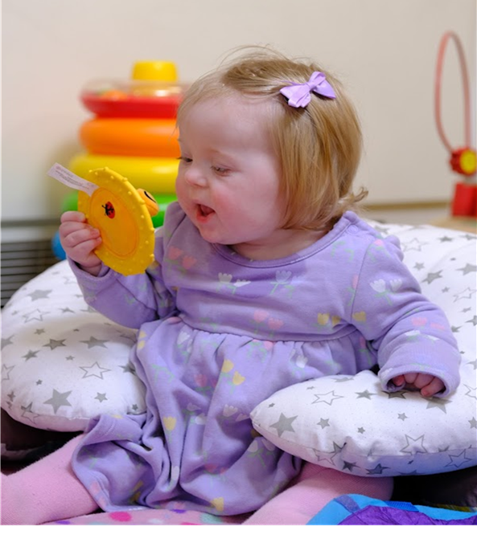
- Education Health and Care Plans
- Transition
- Preparing for Adulthood
- The Local Offer



Introduction

This document is intended to support Early Years practitioners in the implementation of the Graduated Approach in their settings and should be used alongside the Graduated Approach Toolkit.

According to The SEND Code of Practice: 0-25 years (January 2015), the Graduated Approach can be described as:

“A model of action and intervention in early education settings, schools, and colleges to help children and young people who have special educational needs. The approach recognises that there is a continuum of special educational needs and that, where necessary, increasing specialist expertise should be brought to bear on the difficulties that a child or young person may be experiencing.”

Sefton Early Years Team

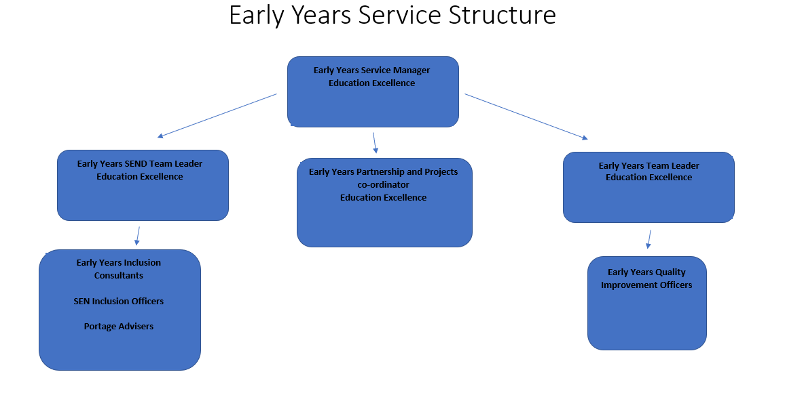

The role of Sefton Early Years Team is to ensure high quality Early Education for ALL Early Year’s children across Sefton including those with Special Educational Needs and Disabilities. Everyone has a role in meeting the needs of all children and ensuring a Graduated Approach.

The Early Years Quality Team:
The Early Years Quality Team comprises of the Early Years Team Leader and Quality Improvement Officers. The team works with schools, settings, childminders and out of school settings to ensure high quality universal provision, also known as ‘ordinarily available’. They provide consultation, support, and training, including Quality Improvement visits.

The Early Years SEND Team:

The EY SEND Team consists of professionals with expertise in the Early Years. Within the team we have, Portage Advisors, Inclusion Officers, Inclusion Consultants and the Early Years SEND Team Leader.

The Portage Service is a home-visiting educational service for pre-school children with SEND and their families. The service also run Stay and Play sessions for families.

Inclusion Officers work directly with Early Years settings to offer early intervention to support with the identification of children with SEND. The officers provide strategies and interventions to support children from two years.

Inclusion Consultants are specialist teachers who work directly with a range of settings and children using their knowledge of Early Years Inclusion to support an adaptive curriculum and the implementation of individual strategies. They also contribute to the ongoing assessments of children’s needs and offer strategic support around Early Years SEND at a local level.

Educational Psychologists
The Early Years SEND Team works closely with Sefton Educational Psychologists to plan and deliver the service and support to individual children and settings. This is primarily focused on the statutory process and transition to school.

Training and SENCo Forums:
The Early Years Team have an ambitious training programme delivered throughout the year which compliments the Graduated Approach. Evidence based training supports Early Years Educators to ensure high quality ordinarily available provision, as well as specific interventions for children who require support that is ‘additional from’ or ‘different to’ what is usually provided. SENCo forums bring together the latest news and updates regarding SEND and run once per term.

All training and Forums can be booked through Sefton Early Years Portal:
https://www.seftoneducation.uk/Services/2151
Working collaborative with parents and carers and professionals:

The Early Years Graduated Approach toolkit has been devised by the Early Years Team in collaboration with professionals, services, partners, and parents. We would like to thank everyone involved for their valuable contribution.

We are especially grateful to the parents and carers who gave their time to give their views and help co-produce this document. This document and the toolkit have been produced in response to their valuable feedback.

Principles underlying the SEND Code of Practice
The SEND Code of Practice describes the principles that should be observed by all professionals working with children and young people who have SEN or disabilities.
• Considering the views of children, young people and their families
• Enabling children, young people and their parents to participate in decision-making
• Collaborating with partners in education, health, and social care to provide support
• Identifying the needs of children and young people
• Making high quality provision to meet the needs of children and young people
• Focusing on inclusive practices and removing barriers to learning
• Helping children and young people to prepare for adulthood
SEND Code of Practice 2015

Definition of Special Educational Needs

A child or young person has SEN if they have a learning difficulty or disability which calls for special educational provision to be made for him or her. For children aged two or more, special educational provision is educational or training provision that is additional to or different from that made generally for other children of the same age by mainstream schools, maintained nursery schools, or other relevant early years providers. For a child under two years of age, special educational provision means educational provision of any kind.

A child of compulsory school age or a young person has a learning difficulty or disability if he or she has a significantly greater difficulty in learning than the majority of others of the same age or has a disability which prevents or hinders him or her from making use of facilities of a kind generally provided for others of the same age in mainstream schools or mainstream post-16 institutions.
SEND Code of Practice 2015

Definition of Disability

Many children and young people who have SEN may have a disability under the Equality Act 2010 – that is:
“a physical or mental impairment which has a long-term and substantial adverse effect on their ability to carry out normal day-to-day activities.”

‘Long-term’ is defined as ‘a year or more’ and ‘substantial’ is defined as ‘more than minor or trivial’. This definition includes sensory impairments such as those affecting sight or hearing, and long-term health conditions such as asthma, diabetes, epilepsy, and cancer. Children and young people with such conditions do not necessarily have SEN, but a disabled child or young person may be deemed to have SEN if they require special educational provision.
Equality Act 2010

The Equality Act (2010)

Sefton is a fully inclusive authority and expects all settings to promote a positive ethos of inclusion. Settings are expected to welcome all pupils with diverse needs with caring and understanding, and to fully support all pupils and their families, during their time in the setting. Setting owners, managers and SENCOs are expected to promote this ethos.
Early years settings must promote equality of opportunity and must not discriminate against, harass or victimise disabled children. Settings must not discriminate:

- directly;
- indirectly;
- for a reason arising in consequence of a disability; or
- by failing to make a reasonable adjustment.

Settings must make reasonable adjustments to ensure that disabled children are not at a substantial disadvantage compared with their peers. This includes adjustments to any provision, criterion, or practice, making physical alterations and providing auxiliary aids and services. This duty is anticipatory: settings must look ahead and anticipate what disabled children might need, for example moving from nursery to reception, and what adjustments might need to be made to prevent any disadvantage.

Responsibilities

The Educational Setting:
The legal responsibilities for disabled children and children with SEN lie with the responsible body (Equality Act duties 2010) or the appropriate authority (Children and Families Act 2014 duties). In both cases this is the governing body for a maintained school, including a maintained nursery school, and the proprietor, that is the owner or the management committee, of a private, voluntary or independent nursery.
Providers must have arrangements in place to support children with SEN or disabilities.
Maintained schools, maintained nursery schools and all providers who are funded by the local authority to deliver early education places must have regard to the Special Educational Needs Code of Practice 2015.

The Manager or headteacher:
The manager or head of the school/setting has responsibility for the day-to-day management of all aspects of the setting’s work, including work with children with SEND. The manager/headteacher agrees policies, works closely with the SENCO on the implementation of SEND and disability policies; and has an important role in enabling and supporting the SENCO to meet their responsibilities.

The SENCO:
The setting SENCO is responsible for supporting colleagues and coordinating the approach of the setting to children with SEN.
This involves:
- Ensuring all practitioners in the setting understand their responsibilities to
children with SEN and the setting’s approach to identifying and meeting SEN
- Advising and supporting colleagues
- Ensuring parents are closely involved throughout and that their insight informs actions taken by the setting.
- Liaising with professionals and agencies beyond the setting
DfE and DH (2015) SEN and disability code of practice: 0-25 years

“Maintained schools and maintained nursery schools must identify a member of staff to act as Special Educational Needs Co-ordinator (SENCO) and other providers (in group provision) are expected to identify a SENCO. Childminders are encouraged to identify a person to act as a SENCO. Childminders who are registered with a childminder agency or who are part of a network may wish to share the role between them.”
(Statutory framework for the Early Years Foundation Stage September 2021)

All Early Years Educators:
All members of staff have responsibilities to children with Special Educational Needs and Disabilities. They must understand these responsibilities and the setting’s approach to identifying and meeting Children’s needs. Where a child is identified as having Special Educational Needs Disabilities, the Code of Practice (2015) envisages that the individual practitioner, usually the child’s key person, will lead the engagement with the child and the child’s parents, with the support of the SENCO, and remains responsible for working with the child daily.

Identifying SEND

The starting point for all children is high quality provision based on Early Years Practice and the Early Years foundation Stage. The principles underpinning the curriculum include:
- Enabling Environments
- Unique Child
- Learning and Development
- Positive relationships.

The Four Broad Areas of Need:

Sefton Early Years Graduated Approach toolkit sets out expected provision using the four broad areas of need set out in the SEND Code of Practice (DfE, 2015: 97-98) These are:

• Communication and Interaction
• Cognition and Learning
• Social, Emotional and Mental Health
• Sensory and/or Physical

In practice, individual children or young people often have needs that range across all these areas and may change over time. The support provided to a child should always be based on a full understanding of their developing strengths and needs. Support should seek to identify primary areas of need; well-evidenced interventions should be employed to target the identified area of need.

Assess, Plan, Do, Review
According to the SEND Code of Practice 2015, all settings ‘should adopt a graduated approach with 4 stages of action: assess, Plan Do and Review’ For most children, this cycle will show progress as children develop in line with expectations. However, for some children, this process could indicate that they may have require provision that is additional to or different from what is usually available.
A delay in learning and development in the early years may or may not indicate that a child has SEN, that they have a learning difficulty or disability that calls for special educational provision. Equally, untypical behaviour does not necessarily mean that a child has SEN. However, where there are concerns, there should be consideration to determine whether there are any factors that may be impacting the child’s development such as environmental factors or prior early experiences.

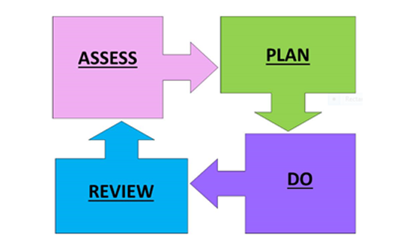

Assess:
Assessment is about noticing what children can do and what they know. It is not about lots of data and evidence. Effective assessment requires practitioners to understand child development. Practitioners also need to be clear about what they want children to know and be able to do. Accurate assessment can highlight whether a child has a Special Educational Need and needs extra help.

The Early Years Educators should work with the SENCO and the child’s parents to bring together all the information to analyse the child’s needs. This discussion will build on consultation with parents about their child’s SEN and the decision to make special educational provision for them.
SEND Code of Practice 2015

Plan:
Where additional support is needed, parents must be consulted. The SENCO should work together with parents and other professionals to agree SMART (Specific, Measurable, Achievable, Realistic and Time bound) outcomes, plan the support a child will get, agree what progress will be expected and decide when it will be reviewed. This should be recorded in a SEND Support Plan.

Do:
Educational provision should be matched to the child’s identified needs, this may be targeted, or specialist support detailed in the child’s SEND Support Plan or statutory as identified in an EHCP.

Provision made for a child should always be based on an understanding of their strength, interests, needs and aspirations. Interventions can be established through practitioners’ knowledge of child development, evidence-based interventions alongside information gathered from parents, carers and those that know the child well.

Review:
There should be a process of ongoing informal review of the support and interventions that have been set for individual children. This must be communicated with parents and carers. It is good practice for SEND support plans to be reviewed at least half termly with parents/ carers, the child’s key person, SENCo. Advice that has been given from professionals during this period should be incorporated into the plan.

Implementing a Graduated Approach

Where a child or young person is identified as having SEN, educational settings should act to remove barriers to learning and put effective special educational provision in place implementing a Graduated Approach. Please note, there will be individual circumstances when access to specialist support needs to be accelerated, for example in preparation for transition to reception or in the case of complex medical needs. In these cases, Early Years Educators can seek advice from the Early Years SEND Team.

Graduated Approach Summary Table:
This table sets out the principles of the Graduated Approach, further guidance and details can be found in the Early Years Graduated Approach Toolkit.
Available for all children | Ordinarily Available Provision  Assess/Plan/Do/Review | - High quality provision, interactions, and environments.  - Valued Characteristics of Effective Learning.  - Adapted curriculum in line with children’s strengths, needs and interests built on their prior knowledge.  - Communication Friendly Environments.  - Strong knowledge of child development to be able to inform assessment.  - Continuous Professional Development and evidence-based practice. | If child is showing a 12 month or more delay in a prime area of learning and development move to targeted support.
Additional to or Different from | Targeted Support  Assess/Plan/Do/Review | - Small group/ short individual evidence-based interventions.  - Developmentally appropriate experiences, resources, and approaches.  - Consider children’s interests and preferences including sensory needs.  - Observe engagement and Characteristics of Effective Learning.  - Signpost parents to community resources and consider if Early Help support may be appropriate.  - Implement a Support Plan as part of the Assess, Plan, Do, Review cycle.  - Accurate assessment e.g., Small Steps Developmental Journal. | If developmental concerns remain despite consistent implementation of targeted support through 2 cycles of ‘Assess, Plan, Do, Review’ refer for specialist support.
Additional to or Different from | Specialist Support  Assess/Plan/Do/Review | - Continuation of the above support with increased intensity.  - Request for involvement through the Early Years SEND Team  - Consider application for Early Years additional resources.  - Strategies recommended by specialists to be included in a SEND Support Plan and implemented consistently.  - Some children may require a Health Care Assessment to support complex medical needs.  - Specialist programmes, resources and/or equipment may be recommended.  - Signpost/refer families for Early Help Assessment if appropriate. | Consider whether a request for Education Health Care Assessment may be required if a child or young person requires Special Educational Provision to be made for them that cannot be provided from within the resources normally available to mainstream settings.

Education, Health and Care Plans
Most children and young people with SEN or disabilities will have their needs met within local mainstream Early Years setting or school. Some children and young people may require an Education, Health and Care (EHC) needs assessment for the local authority to decide whether it is necessary for it to make provision in accordance with an EHC plan. This should be requested where the provision cannot reasonably be provided from the resources normally available to mainstream settings. In most cases the setting should have already implemented the support available from its own resources. Further information about the Education Health Care Assessment Process can be found on Sefton’s local offer.
SEND Code of Practice 2015
Transition:
Children with SEND will often require an ‘enhanced transition’ this may involve additional school/setting or room visits and the use of visual aids and resources to prepare them. It is essential that important information is shared (with signed parental permission) with staff in the child’s receiving room, class, school or setting. Sefton Early Years Transition Day provides an excellent opportunity for this as this is supported by the Early Years SEND team. The Early Years team have developed a transition passport for all children. Additional reports from other services should be attached to the Transition passport.
The SEND offer from individual schools should be published on the Local offer website and parents should be signposted to look at this when they are choosing a school.
The Early Years SEND Team will work with the child’s current setting and the school to identify any additional support needs the that they may need. Some children will require reasonable adjustments to be made for example to teaching, environments and resources and this should be discussed as part of the transition process. Other children may require additional resources or specialist equipment to be provided.
Applications for mainstream school places open in the Autumn term before the child is due to start.

Transition for Children with an EHCP
When children have an Education Health Care Plan and are due to start in reception, the process of identifying and naming a school will be led by the SEN Casework Officer through the EHCP review process in partnership with parents and carers.

Preparing for Adulthood:
Preparing for adulthood is a gradual process starting from the Early Years. This toolkit looks at ways to raise aspirations and expectations and consider what the future may look like for children from an Early age. It can be used to decide outcomes for the child taking the child’s ‘voice’ and the views of their parents and carers into consideration.

PfA outcomes Tool.pdf (councilfordisabledchildren.org.uk)
The Local Offer:

The SEND Code of Practice (2015) identifies that:
‘Local authorities have a duty to publish a Local Offer, setting out in one place information about provision they expect to be available in their area across education, health and social care for children and young people in their area who have SEN or are disabled, including those who do not have EHC plans.’

https://www.sefton.gov.uk/localoffer

