Sefton Early Years & Childcare
Partnership Strategy
2024 – 2029

Foreword

In developing this strategy, we have considered our Joint Strategic Needs Assessment and reflected on many of the plans and previous engagement activity within Sefton including the Children and Young People’s Plan, the Emotional health and Wellbeing Plan as well as our partnership Vision for 2030. In doing so we have linked closely to the four themes in the Children and Young People’s Plan – Heard, Happy, Healthy, Achieving.
Our vision is that, ‘All children and young people should receive an education in Sefton which enables them to reach their individual potential and to engage positively with others in their community’ is echoed throughout all our intended actions and impact.
Our partnership working is key to ensuring the success of the strategy and ensuring that all our children and young people succeed. We will work closely with our partners and link closely to the Children and Young People’s Plan to ensure a joined-up approach that supports all our children and young people’s life chances.
The strategy demonstrates the Council’s role in system leadership, supporting families and early years providers to enable Sefton children to have the very best start in life during the crucial 1001 days.
Councillor Diane Roscoe Cabinet Member, Education Excellence

Introduction
We believe that every young person in Sefton is entitled to receive a good start to life, through access to strong early education and care. The value of early education cannot be underestimated. Giving children the best start in life helps them fulfil their true potential, living happier, healthier and more prosperous lives.
This strategy has been developed to capture our collective ambitions for our children and to outline our direction of travel for our improvement journey. This will enable all stakeholders and professionals to consider how they invest time and resources to prioritise the areas that will have greatest impact on improving educational outcomes for children and their families.
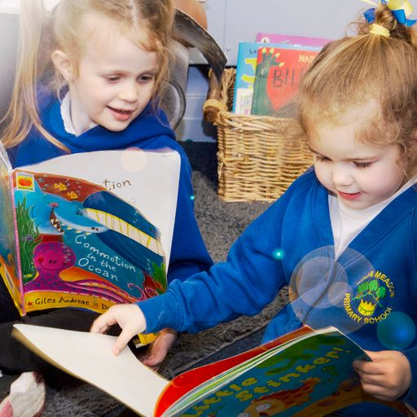
The emphasis of the strategy is to establish a shared responsibility amongst all professionals to ensure they play a part in supporting all children to thrive. This will enable the key steps to be in place supporting positive experiences for both children and their parents. This will lead to a smooth transition to school in order that they are ready to learn and are able to reach their expected level of development at the end of their foundation stage.

“In the right light, at the right time,
everything is extraordinary.”
Aaron Rose, Film Director

Sefton Early Years & Childcare Vision

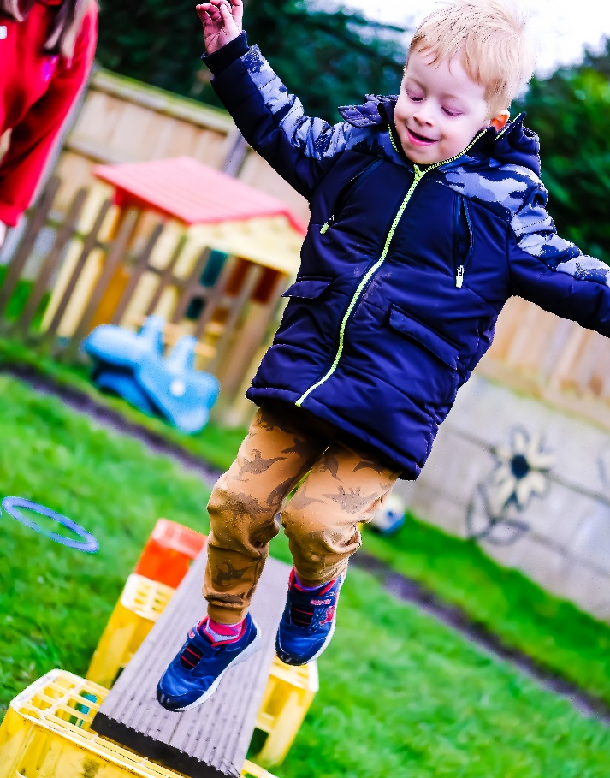
The vision is to give every child the best start in life by building resilient communities, raising aspiration, and working in partnership to deliver high quality, inclusive services that are accessible, tailored to local needs and make a difference to children, young people and their families by:
- Improving the quality of early education and childcare across the borough to lay the foundations for lifelong learning, raise attainment for all children and close the gap in learning and development between children experiencing multiple challenges and their peers;
- Strengthening opportunities for integrated working with key partners in health, Social Care and the Voluntary Sector to make sure that Early Years services are easy to access, inclusive and make sense for families
- Promoting engagement with the whole Early Years Childcare sector to develop a quality improvement strategy that recognises the experience and expertise of practitioners with a trajectory of excellence
- Securing sufficient, sustainable and inclusive Early Years provision across the sector through prudent management and information sharing with key partners.

“Those who don’t jump, will never fly.”
Leena Ahmad Almashat, Author

Statutory Responsibilities

The Childcare Act 2006 identifies the following priorities:
- Delivering the Free Early Education Entitlement for all three- and four-year-olds and 40% of the most disadvantage two-year-olds.
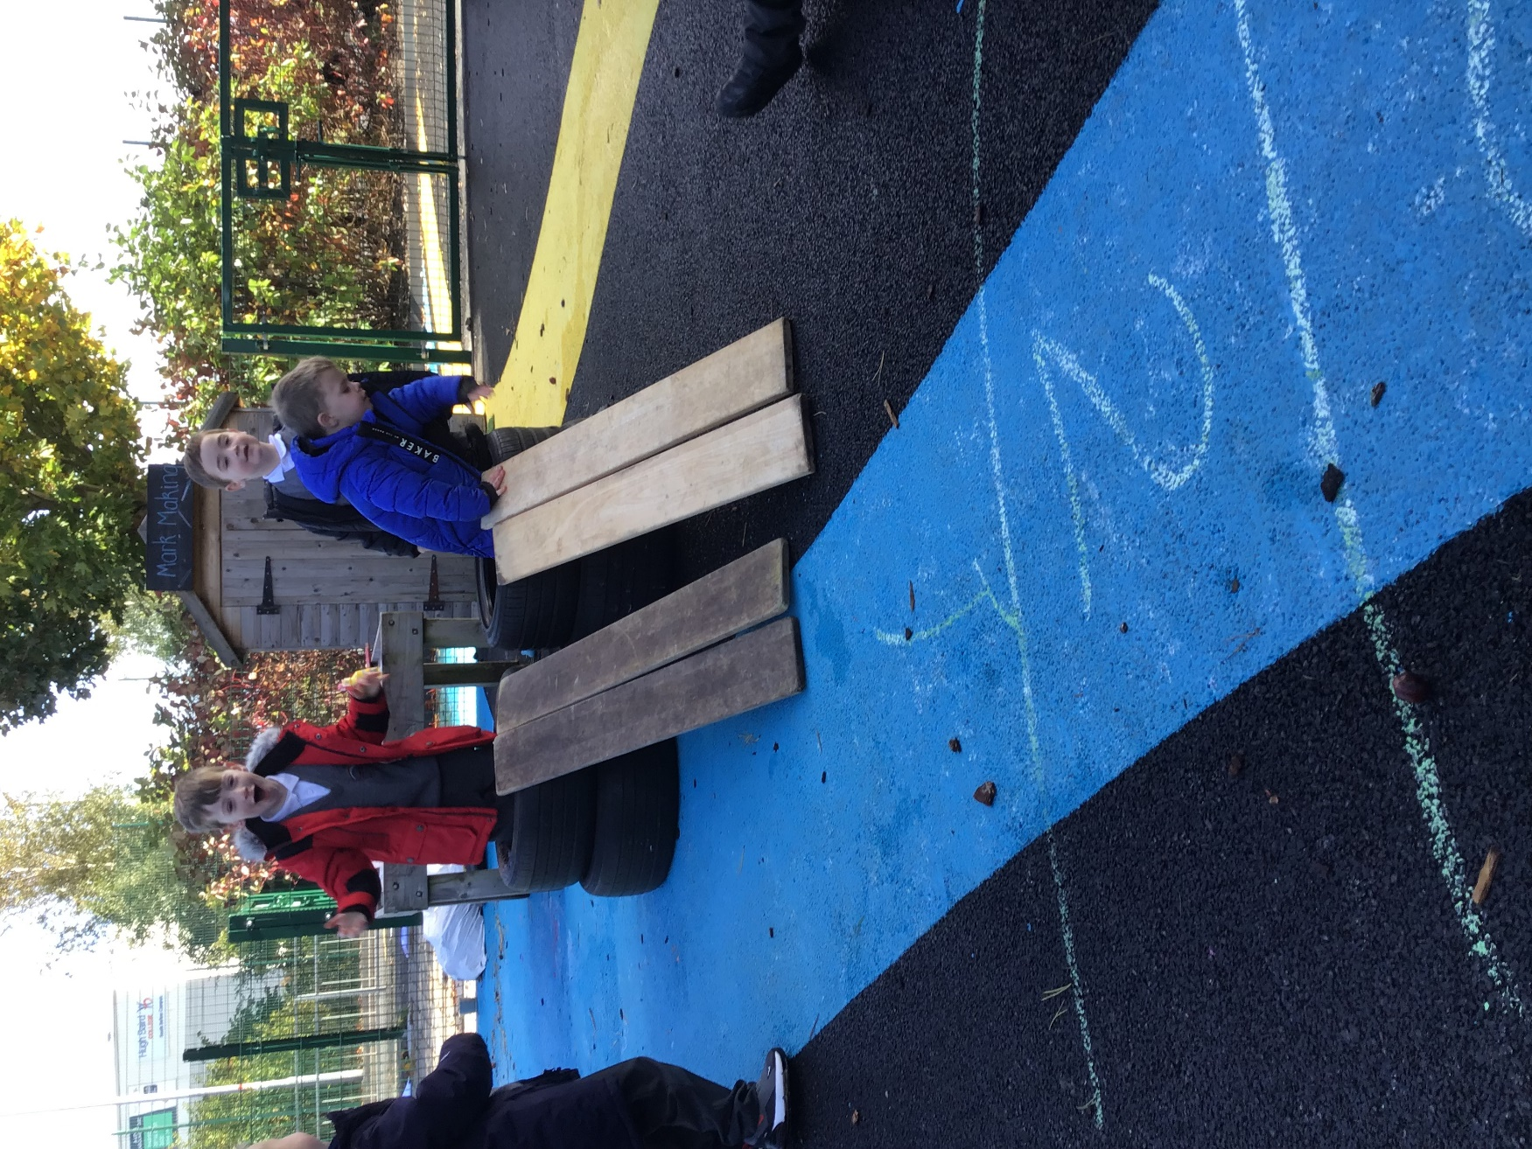
- Offering 30 Hours Free Childcare for eligible working parents of three- and four-year-olds.
- Making effective use of the Early Years Pupil Premium and Early Years SEND funding, including the Disability Access Fund.
- Securing sufficient Children’s Centres to meet local need with integrated provision of Early Years services.
- Maintaining sufficient childcare to meet the needs of working parents or parents in education or training.
- Providing support and professional development opportunities for all early years settings deemed ‘Inadequate’ or ‘Requiring Improvement’ with a power to support continuous quality improvement for all providers.

“The future doesn’t just happen, we are building it and we are building it all the time.”
Hannah Fry, Mathematician

National Context

It is acknowledged that early childhood experiences provide a platform on which future development and learning is built upon. It is now recognised that the earliest years of a child’s life can have an important impact on his or her long-term development. These are formative years, physiologically, cognitively, socially and emotionally.
For a child to flourish and fulfil their potential, they need an environment which provides them with specific types of support from conception to the age of five. The parent or primary caregiver is the most important part of a child’s environment, and attachment has long been recognised as a key factor in positive child development.
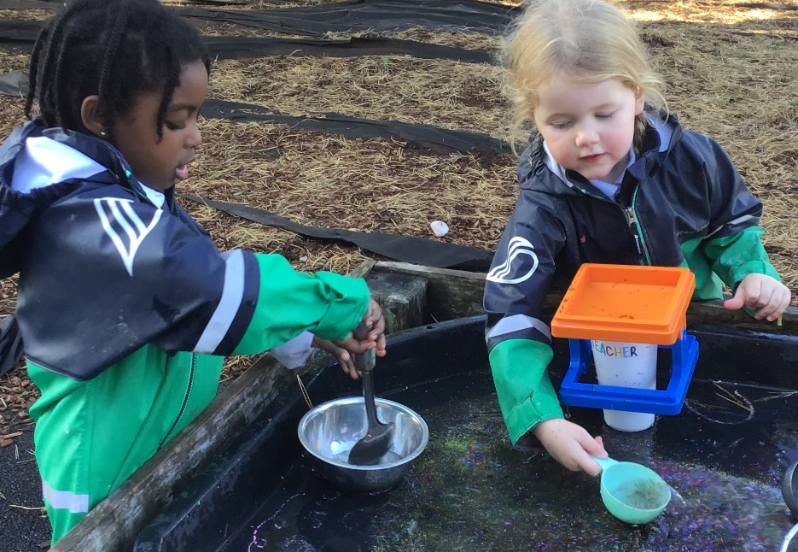
Sefton Council places priority on:
- Promoting social mobility through the delivery of coherent and integrated Education, Health and Family Support Services.
- Aligning the Early Years Foundation Stage Statutory framework and Healthy Child Programme, using data effectively to ensure that every child can make good progress in their learning and development.
- Promoting access to universal three- and four-year-old 15 hour offer and eligible two year old offer.
- Promoting access to funded entitlement childcare for eligible working parents.
- Building a coherent, self- improving sector to give every child a good start in life.
- Encouraging engagement with Family Well-being centres and Early Help with a focus on prevention and timely support.

Department for Education – Expansion of Early Years Entitlements

During his first Spring Budget on 15 March 2023, Chancellor Jeremy Hunt announced the expansion of ‘free childcare’ for working parents in England, extending the existing scheme – currently targeted at parents with three and four-year-olds – to children from 9 months of age until they start school.

The plans are part of a Government drive to encourage more people back to work and to boost economic growth. The Chancellor acknowledged that childcare costs in the UK are amongst the highest in the world, and have been identified as a barrier to parents – particularly mothers – going back to work or working full-time.

The Chancellor’s key announcements on childcare in the Spring Budget were:

30 hours free childcare scheme expanded in England to children from 9 months

Currently, many working parents in England with three and four-year-olds are eligible for the 30 hours free childcare scheme. The new plan will extend this scheme to eligible families with children from 9 months up to 2 years old.
This will mean that all eligible households will be entitled to 30 hours of free childcare for 38 weeks of the year (during term time) for children aged 9 months to 4 years. It is anticipated that this will lead to a significant reduction in childcare costs for families.

To manage this, the scheme will be introduced in stages to ensure there is enough supply in the market:
- Initially, from April 2024, 2 year olds will receive 15 hours of free childcare
- From September 2024, this will be extended to children from 9 months
- From September 2025, the 15 hours will increase to 30 hours.

Additional funding for wraparound childcare provision

The Government will allocate funding to local authorities in England to support additional wraparound childcare provision in schools or in collaboration with other schools, private providers and childminders for school age children from September 2024, with a view to all children having access to sustainable wraparound care (8.00am to 6.00pm) by September 2026. This will be funded by parents however, some families may be able to have access to tax free childcare.

Changes to staff ratios

The Chancellor confirmed that childcare providers in England will have more flexibility in how they can operate, with an ‘optional’ change introduced for the minimum staff to child ratios when caring for two year olds, moving from 1 carer to 4 children to 1 carer to 5 children, to align with Scotland.

Financial incentives for childminders

Reflecting on the decline in the number of childminders in recent years, the Chancellor introduced a new pilot of a financial incentive payment for childminders in England, aimed at encouraging more people to join the profession. This will be a one off payment of £600, rising to £1,200 for those joining through an agency.

Unlocking Talent- A Plan for Social Mobility

A strong early years education is the cornerstone of improving social mobility and therefore the focus of our first life-stage ambition in this plan.
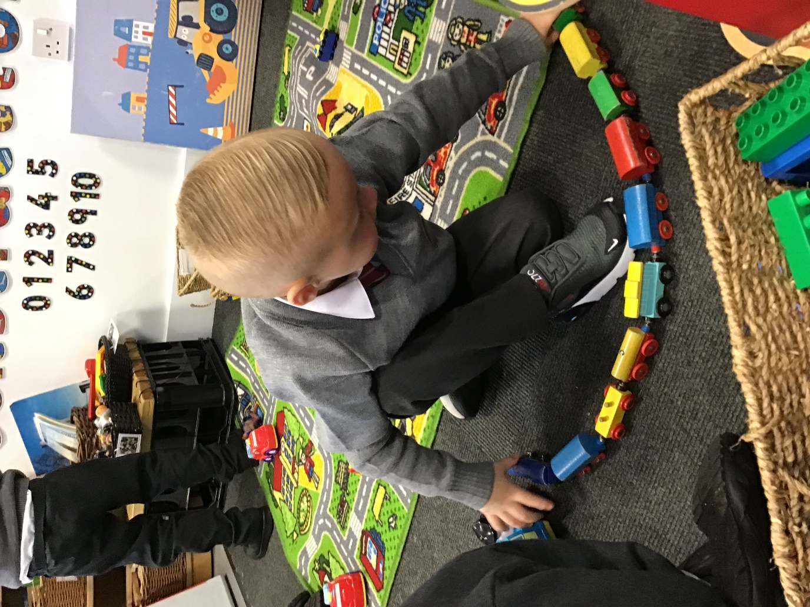
These key years provide the opportunity to ensure that all children develop the strong cognitive, social and emotional foundations on which future success is built.

Best quality early years settings are proof that prevention is better than cure, putting children from all backgrounds on the right track from the very beginning and enabling them to begin school in a position to thrive.

“Look at yourself in the mirror and don’t be afraid to notice how beautiful you are.”

Yoko Ono

Sefton Child Poverty Strategy
The Sefton Early Years Strategy is aligned to the Sefton Child Poverty Strategy 2022: Sefton’s Tackling Poverty Strategy sets out a blueprint for our approach to tackling child poverty in Sefton.
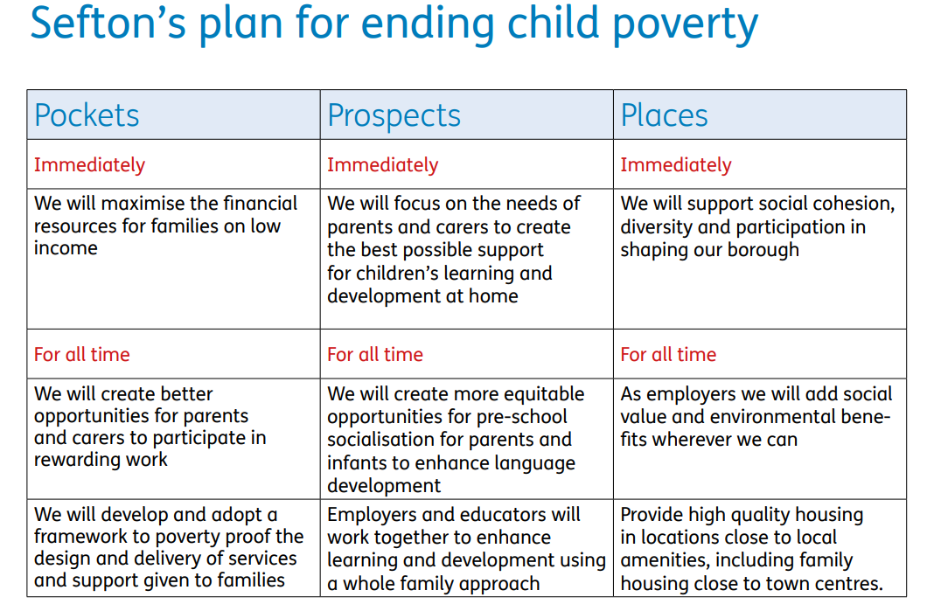

The 1001 Days Critical Manifesto

This highlights the period between conception and a child’s second birthday as a critical time. During this time of rapid growth, babies’ brains are shaped by their experiences, particularly the interactions they have with their parents and other caregivers. What happens during this time lays the foundations for future development. Pregnancy and the birth of a baby is a critical ‘window of opportunity’ when parents are especially receptive to offers of advice and support.
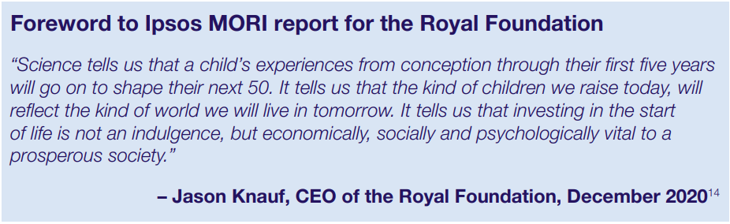
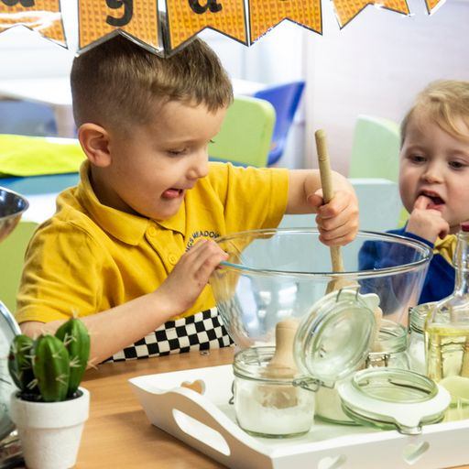

“Children are not a distraction from more important work. They are the most important work.”
C.S. Lewis, Author

Early Years Foundation Stage

A secure, safe and happy childhood is important in its own right. High quality parenting and early learning together provide the foundation children need to make the most of their abilities and talents as they grow up.

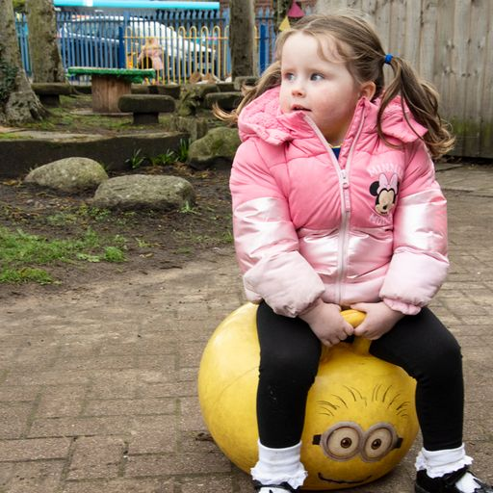
The EYFS framework:
- sets the standards that all early years providers must meet to ensure that children learn and develop well
- ensures children are kept healthy and safe
- ensures that children have the knowledge and skills they need to start school
“The role of education is to interest the child profoundly in an external activity to which he will give all his potential.”
Maria Montessori, Educator

Local Context

Investing in the early years of a child’s life with effective evidence-based interventions, with both universal services and also targeted approaches with families and children at risk, ensures all children will have improved outcomes and reduces inequalities. The cost benefit of this approach in terms of an ‘invest to save’ model for the future is also clearly evidenced.
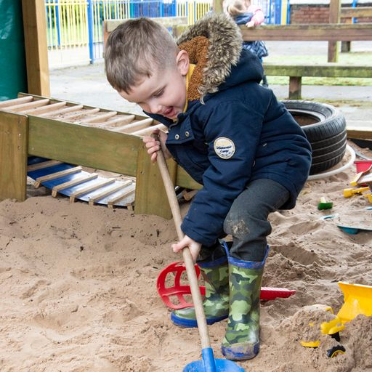
Early intervention services directly support the most vulnerable children and families who require additional and intensive support, focusing on improving outcomes. Services aim to improve the resilience and well-being for children and families and ensure they are able to access the right services at the right time in the right place. They also aim to make a significant difference in reducing demand for statutory services and to provide support to families who are stepping down from statutory services.
This approach helps to provide responses to the most vulnerable families and reduce inter-generational cycles of poor outcomes. The approach has far-reaching implications, which extends to both universal and targeted services who work with adults, young people, children and families and who work across all sectors.
It aims to respond in a meaningful, supportive way, working with parents whenever possible. It takes into account that everyone involved with the family has an important part to play and puts wellbeing of children and families at the heart of any support.
“The best way of learning about anything is by doing”
Richard Branson

Sefton Specific Data
Percentage of children - funded education 2021
Area | 2 YO | 3-4 YO
Sefton | 84.0 | 96.0
North west | 76.0 | 96.0
SNs | 80.0 | 96.9
England | 72.0 | 92.0
National rank and band | 26 | 36

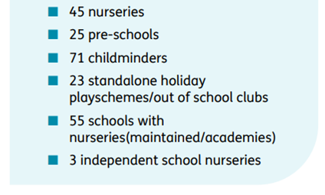
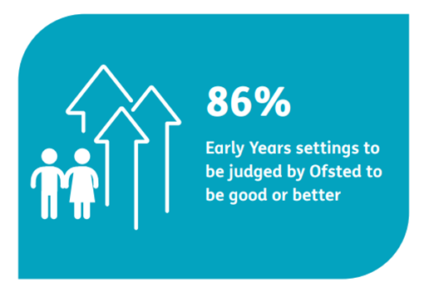
222 Early Years Providers
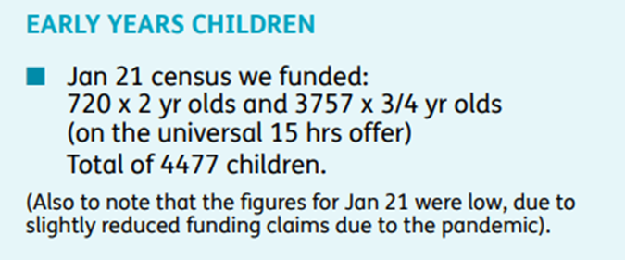

Sefton Education Excellence Strategy

The Sefton Early Years Strategy is aligned to the Sefton Education Excellence Strategy 2022-2027 with the below priorities:
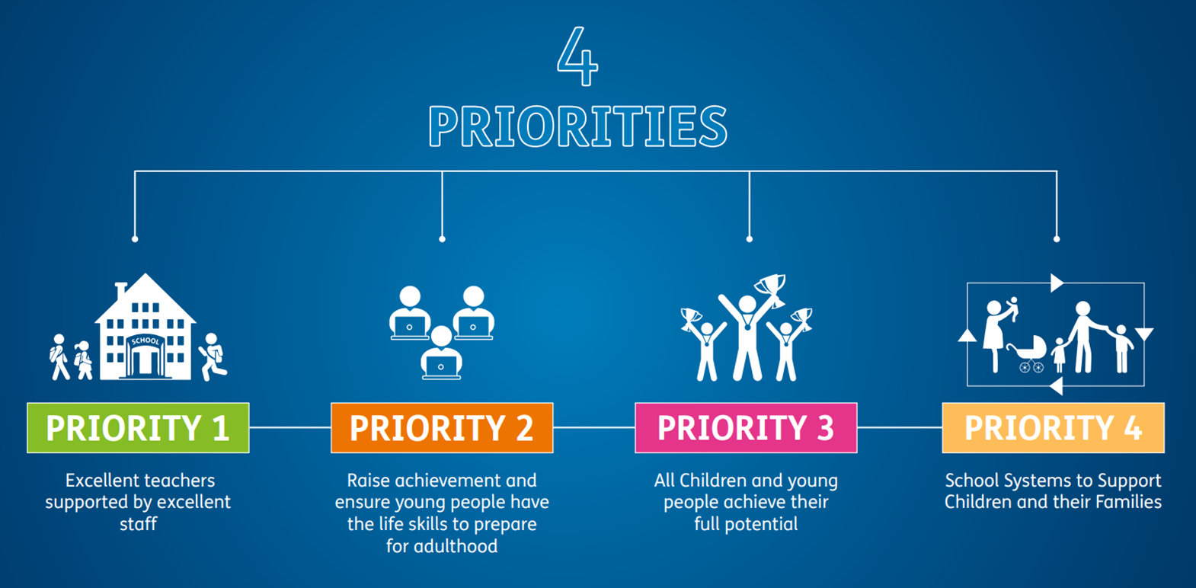

Early Years and Childcare Strategy

From conception through to the first day at school, parents, babies and young children have regular contact with a range of different services including midwifery, health visiting, GPs, Family well-being centres, childcare and early education provision. The early years is a crucial stage in human development, brain development begins before birth and rapid and intensive throughout the first three years of life. A young child’s development is profoundly affected by their early care-giving experiences.
An effective Early Years Strategy needs to be based on the assumption that parents are the first educator and ensure that there is a robust system in place to support them in this vital role.
Research shows social class, income, co-parental relationships, living conditions and parent’s own education levels are directly related to child development outcomes. However, the quality of the early home learning environment (from birth) acts as a significant modifying factor. All parents can enhance their child’s progress if they engage regularly in activities that encourage positive social development, communication and thinking. Children with strong early home learning environments are ahead in both social and cognitive development at the age of three. They show secure language ability, higher levels of confidence, co-operation and sociability, and this advantage continues as they progress through school.
Services need to be focussed on delivering an approach that is underpinned by supporting parents in good parenting skills. This will provide the basis for them to understand how a child learns and ensure that they are an active participant in their child’s brain development, enabling the child to become an active learner with a strong attachment and healthy relationships.
Whilst parents are recognised as the child’s first educator, this strategy recognises the impact that access to high quality education can have in improving outcomes for children. Research shows us that access to high quality educational experiences can have a significant impact on the outcomes a child achieves. This strategy has a strong focus on building upon the good and outstanding provision that exists within Sefton.

Strategic Aims

Our primary aim is to increase the Good Level of Development (GLD) of children across Sefton and to improve out outcomes when compared to statistical neighbours. The key to ensure our success will be to:
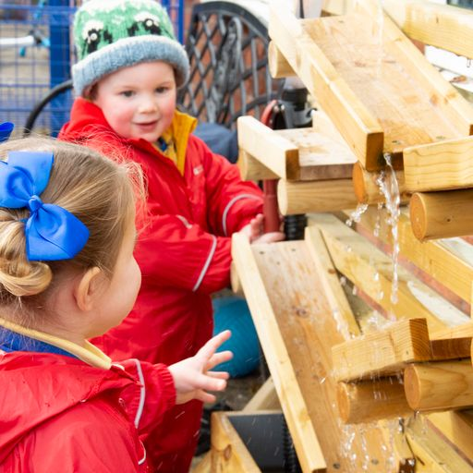
- Embed a shared understanding across the wider workforce as to the importance of the work with families in their earliest years and the positive impact this has on their outcomes at the end of the foundation stage.
- Ensure all professionals working with parents and children through their journey from pregnancy to end of the foundation stage deliver effective consistent messages
- Encourage all stakeholders and agencies target their resources effectively by using the data and information provided in the Early Years Sufficiency report.
- Enable a skilled multi-agency workforce to deliver evidenced based interventions which respond to changing local needs
- Empower representatives of the early years, school sector and key professionals from across the system, to come together to be a fundamental driving force for this strategy, with responsibility for the delivery of our ambitions.
- To enable a multi-disciplinary workforce to share key messages and understand their role in the system this strategy sets out Sefton’s approach to supporting families on this journey and will enable all services to meet need in a consistent way.

Putting Children First

Children will be given every opportunity to:
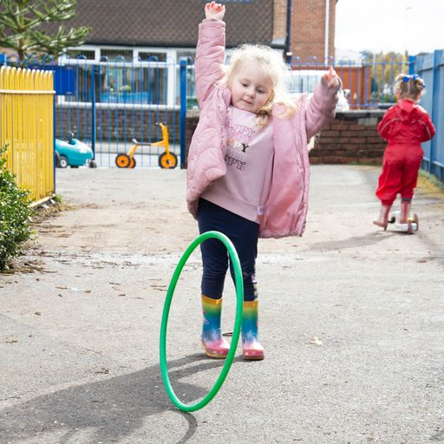
- Be Healthy - Grow, develop and thrive
- Be Happy - Play, have fun, socialise and access their Early Years entitlement
- Achieve - Embrace learning and get the most out of going to school
- Be Heard – Listened to and have their needs met at the right time in the right way

Parents and care-givers will be supported to:
- Be healthy and well before, during and after pregnancy
- Positively embrace parenthood and bond with their baby
- Enable their child to grow, play and learn
- Know how and when to access services and support, to meet their own and their child’s needs.

Services will be enabled and equipped to:
- Use evidence informed practice
- Have well trained and supported staff
- Work collaboratively to ensure children, their parents and care-givers are at the heart of how we plan and deliver services
- Maintain a key professional wherever possible.

This approach reflects the UNICEF principles that school readiness is achieved by communities and services working together for all our children giving them the best opportunity to thrive.

Language Development

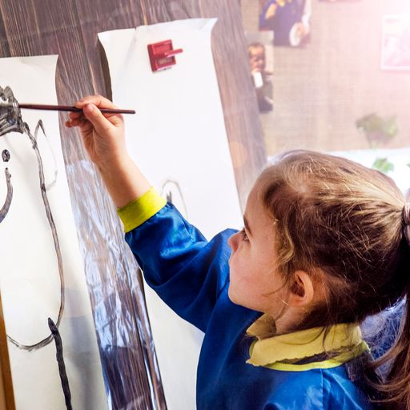
One of the earliest areas of cognitive development and an important stepping stone to future success – is also influenced by parents or caregivers. If adults talk with children effectively – taking the lead for the child, elaborating on what they say, asking questions, sharing rhymes or songs or books – then children are given the best start in developing the cognitive tools they need to succeed at school.

A smooth transition into school enhances a child’s ability to learn and this has a fundamental impact on their life chances in adulthood. This is referenced across a number of key documents nationally.

“The most important thing in communication is hearing what isn’t said”

Peter F Drucker

Our Values

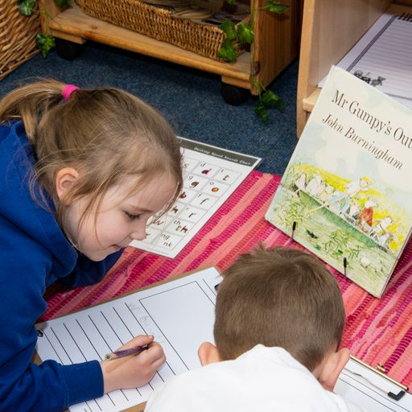
We are accountable for the delivery on the promises we make and take responsibility for our actions and the outcomes achieved.

We will have the courage to communicate openly and honestly, challenging the status quo and using our independence and experience to lead change for children in all our activities.

We take pride in delivering quality services that are community focussed and based on listening carefully to what the families need.
We will respect all children and seek to foster respect for them in others.

We are trustworthy and all our dealings with children and families will be honest and transparent in the decisions we make and the services we offer.

We are compassionate, caring, hardworking and committed to deliver the best services that we can with a positive and collaborative attitude.

“Equipped with five senses, man explores the universe around him and calls the adventure,
science”

Edwin Hubble, Astronomer

Vision One
Children and their families achieve their potential with support from an effective and connect Early Years system that has a clear vision, purpose and direction.
Aims and Aspirations | As a Local Authority we will:
1. Wide collective ownership of the Early Years and Childcare Strategy from a range of partners who are willing to make commitments to furthering its aims. | - Introduce, embed and extend the Early Years and Childcare strategy as appropriate and necessary across all services  - Ensure all partners in the Early Years system sign up to this strategy, consider the implications for their own practices and align what they do to the intended outcomes.
2. All aspects of the system feel that their contribution is recognised and valued | - Ensure all partners in the system understand and appreciate the role of others to identify ways in which they could work more effectively and maximise on the benefits of effective multi agency working.
3. Partners work in collaboration identifying and exploiting opportunities for improved integration wherever possible | - Support everyone across the system to target activity to the same identified groups who are most in need of support.  - Extend the provision of Early Years and Childcare Briefings, Networking sessions and Bulletins.  - Implement a ‘database’ system which produces a chronology or ‘passport’ for each child giving information about support and services that have been accessed.  - Extend the promotion of working in formal collaborations across key stakeholders within Sefton and across Liverpool City Region.  - Development of central 0-5 year communication tools including, social media, a developed website and early years portal which are attractive, easy to navigate and shares the same key messages across services for maximum impact in partnership with Early help.
4. Agencies, settings and practitioners work together across barriers and boundaries to share good practice, insight and training and development opportunities aimed at developing mutual understanding of each other’s roles and strengthening the sector. | - Develop a strong Early Years leadership structure with clear job descriptions and roles within each level with a strong ethos of accountability.  - A strengthened communication system within professionals to ensure joined up working is successful, with an ‘annual event’ workshop which brings services together.

Vision Two
All children have a positive journey through their Early Years ensuring that they are school ready and are well supported to transition to Reception and start Years One.
Aims and Aspirations | As a Local Authority we will:
1. Transition across the system is well managed, contributed to by a high level of trust between partners | - Support senior leadership teams in schools and early years settings to have a commitment to good, consistent transition as well as to respect individual aims and ethos.  - Promote strong, integrated working between early years settings, childminders, schools, wraparound provision and other agencies.  - Ensure children are supported to prepare for transitions and relevant strategies and resources are shared to ensure consistency and continuity in their new school.  - There is a recognition that enhanced transition arrangements will be needed for some children – with the implementation of a Transition Policy.  - Ensure continuity of support for children with SEND from specialist teams across early years settings and schools. Multi agency working around the needs of children and families.  - Lead and embed whole team transition events which bring services together to share knowledge and expertise.
2. There is an agreed system wide approach to and acknowledgement of the importance of early language and communication, and relationships and attachment to children’s development | - Develop training materials, opportunities and practice to support providers in implanting changes in practice that will impact on children’s outcomes.  - A clear and succinct language pathway will map out the expectations for language development across services to ensure a collaborative and high quality approach.
3. All children are well supported by the families and agencies which they work with and as a result receive lifelong benefits from having a great start in their Early Years through to becoming responsible adults. | - Embed the Graduated Approach in order to support early identification of needs.  - Support Early Years practitioners and health visitors to review and reflect on the integrated two-year-old check looking ahead to ‘school readiness’ and identifying the gaps in support for parents and carers and their child’s early development.
4. Everyone, including parents, understands the role they play in supporting children to prepare for starting reception class at school and moving through this into year one. | - Develop a shared understanding of the term ‘School Readiness’ and the role of each service including parents within this.  - Ensure early years settings and schools share expertise and work effectively together to ensure effective transition for children starting school.  - Schools’ will demonstrate a commitment to providing a positive and inclusive early years’ experience through reception to year one which meets the needs of all children.  - Develop a clear pathway for parents and professionals that promotes a secure understanding of every child’s development.  - Ensure a secure understanding of the Early Years Foundation Stage Curriculum by parents and professionals, particularly in relation to the Characteristics of Effective Learning and how these can be developed in daily life.

Vision Three
Children who are at risk of poor outcomes are prioritised for high quality targeted support.
Aims and Aspirations | As a Local Authority we will:
1. The system understands which children are less likely than others to achieve against standard measurements, for e.g. GLD and has embedded understanding of how to support these children to achieve they individual potential. | - Analyse early years data to identify trends and gaps in children’s development and use this to identify training needs, support and possible interventions required.  - Encourage early years practitioners to collaborate and analyse GLD data within clusters to identify needs and strengths across schools and the borough to inform school development plans and early years practice.
2. There are strong and effective systems which identify children who need additional support at an early stage and once identified practitioners use a range of targeted early interventions to provide effective early support. | - Support the sector to implement the Graduated Approach, including early identification and offering targeted interventions to improve outcomes particularly around communication and interaction.  - Review how health notifies the LA of children who have SEN or who are likely to have SEN.  - Develop Early Years PEP in collaboration with the Virtual School to raise outcomes for children who are cared for.
3. The system focuses on those who are in most need and enables them to receive effective early help, including a specific focus on improving experiences of children with SEND. | - Support greater understanding and identification of SEND team functions, extend the principles of inclusion, being explicit in all support and training opportunities so providers are increasingly upskilled to match age and developmental stage and that learning gaps are quickly identified.  - Extend support for the professional development of early years setting SENCos through training and the sharing of effective practice.  - Ensure all early years and childcare providers being aware of their duties under the quality act and send code of practice and embed the quality and capacity of providers ability to meet the needs of local families and their children with SEND  - Work in partnership with the wider Inclusion services and health agencies.
4. Everyone has a good understanding of the groups of children who may be less likely than others to have good outcomes and targeted support is provided at an early stage to enable these children to reach their potential. | - Ensure everyone who works with children under five is alert to children who may need extra support and to ensure that those children are able to access the extra support that is available.  - Ensure a sharp focus on children’s emotional wellbeing and explore the avenues of support for children who have experienced significant trauma.  - Ensure a supportive and aspirational vision for children who are cared for, those on child protection, child in need plans and those with wider vulnerabilities.
5. We are committed to learning more about and from disadvantaged groups and taking innovative approaches which we will learn from to inform our longer term strategies. | - Support access to early years provision for children with SEND in partnership with providers.  - A clear system will identify children eligible for Early Years Pupil Premium, and support children and their families in accessing a suitable two-year old, funded place following a professional referral.  - Cared for children will be prioritised for a place in early years provision with a well-informed PEP to closely monitor their progress and identify any further areas where support may be required.
6. All settings are inclusive and so capable of meeting the diverse needs of all children. | - Deliver training to explore the meaning of inclusion and how this translates into practice ensuring a robust system which implements ‘the Graduated Approach’ and adaptive teaching.  - Offer specific SEND training, delivered when necessary, focusing on current trends and needs gained from feedback from providers, QIO’s and Early Years Leads.  - Offer advice, support and training to Early Years and childcare providers to enable them to promote inclusive learning environments able to meet the needs of children with SEND.  - Recommend attachment and trauma informed training and promote throughout the sector and in partnership with the wider children’s services.  - Ensure specific speech and language support is offered through advice from experts and a range of different tools to support this, such as WELLCOMM and ELKLAN.
7. All professionals have a secure understanding of Child Development and are flexible in their approach to meet the needs of each unique child. | - Reasonable adjustments and adaptations are implemented routinely to meet the needs of all children.  - Professionals have a positive and welcoming approach for all children and their families as they constantly explore how the local offer translates through the service they provide.  - Key stakeholders, for e.g. Senior Leadership Teams in schools and Ofsted, will be challenged to understand how Early Education can be delivered flexibly and with a unique approach to meet the needs of individual children. There is no ‘one size fits all’.

Vision Four
Children’s early learning and development is expertly supported by a strong, skilled, and knowledgeable Early Years childcare system workforce.
Aims and Aspirations | As a Local Authority we will:
1. Careers in Early Years in Sefton are well respected, valued and popular; recruitment and retention rates across diverse groups are good. | - Support Early Years and childcare sector in Sefton to be strong, well-led and appropriately skilled to effectively support the needs of all children and families.  - Promote the profile of working in Early Years in Sefton - through middle and higher education and through marketing approaches including the re-design of the website and the use of social media platforms.  - Ensure induction and support packages are used effectively to ensure all new staff to early years including apprentices are nurtured and invested in leading to a motivated and skilled workforce at every level.
2. All children are supported to access high quality early years provision and are supported by skilled and knowledgeable early years practitioners. | - Support providers (PVI, childminder, OOS, Early Years within school) in developing their quality provision through universal and targeted support.  - Where a provider receives an OFSTED judgement of less than good, the LA will deploy targeted support to transition the provider back to ‘good’.  - Devise and deliver high quality training to all Early Years providers which is reflective of the needs of Early Years children, the needs of schools and settings and is responsive to issues arising through standardisation sessions, Ofsted, quality improvement visits, DFE guidance and the Early Years Curriculum.  - Support providers to self-audit their provision so that they can work towards being an Outstanding provider by sharing a suite of audit tools.
3. The Early Years Workforce is enabled to access a training and development offer which meets its needs and is joined up and co-ordinated between the different agencies and contributes to continued and sustained professional development, taking into account the latest research. | - Seek out opportunities that are funded by the DFE and other sources to secure training opportunities that are evidence based or of National recognition  - Develop a yearly training plan which will be circulated to the whole early year’s workforce in a timely manner and will be promoted in network meetings targeting specific audiences.  - Develop a central, concise and up to date website to ensure settings know which training is available and will optimise attendance.  - Promote the profile of a career in Early Years through middle and higher education and marketing approaches.
4. Training accessed translates into a positive impact demonstrated through both the outcomes achieved by children, the quality of settings and changes in practice. | - Introduce a universally available SEND training package to ensure a baseline of knowledge and understanding of effective inclusive practices is achieved.  - A Graduated Approach toolkit detailing an ‘Ordinarily available provision’ which is referred to by all professionals and gives the same consistent advice and key messages.  - Offer project-based training to increase impact, knowledge and understanding and ensure sustained changes in practice are achieved.  - Support the workforce to demonstrate an in-depth knowledge of child development and how to support families in having high expectations and being confident in how to support the early education of their child.
5. Ensure the ‘Child’s Voice’ is at the heart of all systems and processes with a tailor made and personalised approach that meets the needs of each individual child and their family. | - Develop a bank of resources which are assessable and used effectively to support each individual child, for e.g. environment audits and visuals.  - Involve the child and their family when making decisions, empowering them to self-advocate and engage.  - Contribute to the Children and Young Peoples plan – ensure that voice of young children is reflected.

Vision Five
Parents choose to access sufficient, high quality and inclusive childcare places that support early learning and childcare needs whilst being enabled to be the best that they can be.
Aims and Aspirations | As a Local Authority we will:
1. Parents in Sefton are supported to be resilient, have their voice heard and to have high aspirations for themselves and their children. | - Support the development of parent and carer forums.  - Offer support to childcare businesses in Sefton to ensure they are well managed, they plan effectively and they offer high quality care.  - All childcare services and professionals will welcome and encourage diversity with an embedded inclusive approach.
2. There is sufficient pre-school and school age childcare in Sefton to meet the needs of working parents and those wanting to access funded entitlements | - Identify a project manager to lead on the expansion of childcare and wraparound provision.  - Work closely with the early years and childcare sector to provide sufficient, high quality places to meet funded Entitlement demands for children aged 9 months +  - All children who would benefit from accessing quality early education provision are encouraged and enabled to do so.  - Marketing activity will ensure maximum take up of funded entitlements by two, three and four year olds as appropriate and necessary.
3. There is good quality information, advice and guidance for parents on finding, accessing and affording suitable early education and childcare. | - Joint work with Early Help, Health Visitors and Early Years settings will support effective outreach to ensure that families are aware of their entitlements and make informed choices about take up.
4. Parents are recognised as key contributors to the early years system and are supported by it to help their children achieve good outcomes. | - Support practitioners in providing information, practical support and strategies to raise engagement with their child’s learning.  - Partnership with health visitors, midwives and Early Help workers will ensure a range of integrated child and family health services and programmes are provided.  - Parent pathways will support parents and carers to find the information which they need which is useful and specific.  - Informal opportunities for parents and carers to meet professionals and understand their role will ensure a supportive and positive experience.
5. Effectively support the long term sustainability of the early years and childcare sector, including working with providers to manage the short, medium and long term impacts of the pandemic. | - Parents will have confidence in schools and professionals and know that the needs of their child will be met through a supportive and collaborative approach.  - Parents are recognised as key contributors to the Early Years system and are supported by it to help their child achieve good outcomes.

Monitoring and Evaluation

The strategy will be supported by a detailed implementation plan. The actions and milestones will be developed, monitored during the life of the strategy to identify barriers or challenges in delivery.
This strategy will be a dynamic hypothesis for change and will be routinely revisited and refined. Its progress and impact will be measured against strategic outcomes and appropriate indicators set out in the Early Years Strategy and Outcomes Framework rather than implementation of specific actions or projects.
Evaluation of the strategy will be informed by consultation and engagement with children, families, the Early Years workforce and key stakeholders from across Sefton.
Outcomes will be captured and ratified by the Early Years Development Group.

“The greatest sign of success for a teacher… is to be able to say ‘the children are now working as if I did not exist.”

Maria Montessori

Thank you

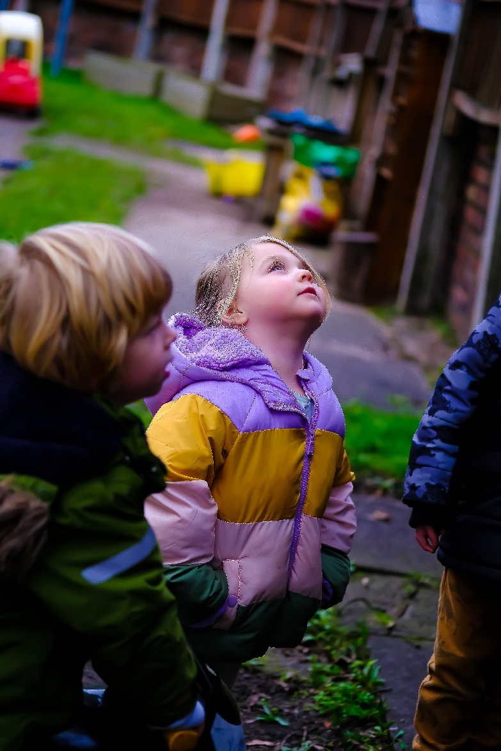
Many thanks to the Early Years Service team, our wider colleagues and partners for their involvement in the development of this document, for their input during the information events and meetings. However, most of all thank you, for your enthusiasm and commitment to improving outcomes for Sefton children.
Thank you also to Rocking Horse nursery, Kings Meadow Primary School, St Mary’s Catholic Primary School, the Portage team and photographer Ollie Cowan for the photographs included in this document.

“If you want a child’s mind to grow… you must first plant a seed.”
Robert Lewis Stevenson

