Looked After Children
Sufficiency Strategy
2022- 2025
Review date: December 2022

Table of Contents
Executive Summary 2
Introduction to the Strategy 5
Sefton Context 5
Needs Assessment 7
Sefton accommodation profile 16
Accommodation Types 16
Accommodation and Support Spend 17
Our Overarching Approach and Principles to deliver this Strategy 18
Integrating provision 18
Listening to our children 19
Placement Stability and Sufficiency 19
Preventing Homelessness 19
Working in Partnership 19
Dynamic and brave commissioning 19
Best Value 19
Our Key Challenges 20
Our response 21
Preparation for Adulthood 23
Voice of the Child 24
Conclusion 25



Executive Summary
Sefton Borough Council Looked After Children Sufficiency Strategy (2022- 2025) sets out our approach to meet the statutory responsibility to provide secure, safe and appropriate accommodation and support to children in care and care leavers, over the next three years.
The Strategy identifies our key principles to deliver the best care and support possible across the borough of Sefton. It identifies the actions that are required to deliver accommodation and support that improves outcomes for our children in or leaving care. It is part of our ambitious plans to transform Children and Young People’s Services in Sefton. Delivery will be aligned with programmes of work which enable us to intervene as early as possible with children and families and drive forward how we work in partnership with our statutory partners, providers, young people with care experience and the voluntary and community and faith sector in Sefton.
The document provides a high- level summary of need, the types of accommodation available and includes current supply along with forecasted demand.
The key actions identified are:
- Strengthen the voice of the child to shape the future market
- Work more closely and innovatively with providers in borough
- Establish a Local Sefton Framework and new models of step-down for residential and foster care to improve sufficiency within borough which is based on the child’s journey from early help to preparation for adulthood
- Further strengthen our internal fostering service
- Deliver a value model that will help us to evaluate the social value associated with interventions and support to those with the most complex needs
- Implement a market review programme listening to the voice of the child and or young person to drive up quality and improve outcomes for children and young people
- Strengthen and consolidate our early help offer to shape an Edge of Care approach to effectively manage demand
- Explore the feasibility of re-launching our internal homes with a new focus in relation to assessment, outreach in relation to edge of care and the facilitation of step down and preparation for adulthood
- Strengthen our leadership and governance in relation to transitions and preparation for adulthood, improving our whole system pathways, outcomes for young people and our whole system commissioned offer
Sefton faces a significant challenge in delivering placement sufficiency. Sefton is a borough with a population of 72,875 children and young people (Children and Young People’s Strategic Needs Assessment April 2021) aged 0-24. This makes up 26% of the boroughs population, lower than the rates seen across the Liverpool City Region, the North-West and England (all with 30%).
Population projections suggest that by 2043, there will be 72,157 children and young people residing in Sefton, a slight reduction of 1% compared to an overall increase in the total Borough population (6%) and in contrast to the 1% increase in young people seen nationally.
However, there were 2,028 children aged between 0 and 17 across Sefton who were children in need on the 30th of September 2020, this equates to 375 per 10,000 children residing in Sefton, 616 were children looked after, a rate of 114 per 10,000 children and 274 on a protection plan, a rate of 51 per 10,000 child residents. This makes Sefton a national and regional outlier as of March 2019 which remains the case to this day.
The market is also significantly affected by the numbers of children placed by other local authorities which as a local importer has placed additional pressure on our infrastructure.
Analysis undertaken to develop this Strategy identifies principles, themes and actions which will enable us to overcome the challenges that we face. The Strategy sets out the need to work in a different way with the market going forward.
It also identifies that there are new and growing issues for specific groups of young people. For example, we have high numbers of adolescents amongst our children in care population with complex and multiple mental health challenges, an increase in child sexual exploitation and a changing number of Unaccompanied Asylum-Seeking Children, a need to improve preparation for adulthood and a clear need for an Edge of Care Offer to manage increasing demand at the front door.
The delivery of placement sufficiency means that we need our children and young people to have access to high quality placements. We want to support children and young people to have placement stability and to have the most opportunities to achieve positive outcomes. We know that the quality of practice and support to meet the needs of children in care, improving their experience of care and achieving permanence is of critical importance. Working together with our young people and their families, our providers and our partner agencies is fundamental to delivering excellent outcomes.
In getting the care and accommodation right for our children and young people who are looked after or leaving care we are giving them a stable platform upon which to develop as individuals and access education, employment and relationships as an adult which leads to happy, healthy, fulfilled and contributing citizens of our communities and wider society.
This Strategy supports the ambition of Sefton to ensure that all our looked after children live and grow up in homes with carers who meet all their physical and emotional needs. Finally, it will define what Sefton intends to do in the future to improve our provision for children and young people in our care.
We want everything the best parents want for their children:
- That they are happy and healthy both physically and emotionally
- That we keep them safe and protected from harm and exploitation
- That we support them into adulthood and that we prepare them for independence
- We are ambitious for our children and we want them to achieve their potential and participate in decisions which affect their lives
- We want them to work with us and, along with parents and carers to shape the services we offer to them

In developing the Strategy and looking at how we will deliver the actions, the following factors will be central to all actions:
- Sufficiency of placements along with the right skilled workforce to deliver the support to children and young people, recognising and delivering good outcomes for our children
- Increasing placement stability with the best assessment, best matching criteria, best provision and best interventions
- Strong leadership with the market, sharing intelligence on existing and emerging trends and co-producing new innovative models
- Being responsive operationally and strategically to continue to build or develop good relationships
- Measuring the engagement and satisfaction of young people, parents and carers using new and existing forums
- Planning and discussing future service options for Move-On and Transition with and for our young
Sefton Borough Council cares deeply and is fully committed to providing the best opportunities for children in care, care leavers and other vulnerable children. This Strategy forms part of its approach to the delivery of that ambition, working in partnership to improve outcomes for children and young people at every opportunity.
The Strategy links directly to the 4 aims of the Children and Young People Plan: Happy, Healthy, Heard, Achieving.
Microsoft Word - Children and young people's plan 2020-2025 [5].docx (sefton.gov.uk)
The Health & Wellbeing Strategy has one of it’s 10 ambitions as “Every child and young person will have a successful transition to adulthood” which correlates with the transitions element of the Strategy.
the-health-and-wellbeing-strategy-2020-2025.pdf (sefton.gov.uk)



Introduction to the Strategy
This Sefton Borough Council Sufficiency Strategy for 2022-25 details how the Council intends to meet its sufficiency duty. This Strategy is a statutory requirement set out in Section 22G of the Children’s Act 1989.
This duty requires ‘local authorities’ to take steps that secure, so far as reasonably practicable, sufficient accommodation within the authority’s area which meets the needs of those children that the local authority is looking after and whose circumstances are such that it would be consistent with their welfare for them to be provided with accommodation that is in the local authority’s area.
Whilst this document is a Sefton Borough Council Strategy it will only be delivered successfully in partnership.
This Strategy brings together our vision, the profile of need and the profile of accommodation. It identifies the principles upon which we will act and our key commissioning challenges and actions to drive better value.
A key element of this Strategy is our desire to develop new local models of good and outstanding provision particularly for our most complex children and for those on the edge of care. Listening to the voice of children and young people will be at the heart of what we do as we drive forward the implementation of this Strategy.
The Strategy reflects the Council’s Vision reflected in Sefton 2030 and My Sefton, Children and Young People’s Plan 2020-25. My Sefton is our single overarching strategic plan for all services which affect children and young people across Sefton. It sets out how the Council with its strategic partners intends to achieve improvements.
We have used information from our JSNA to inform the Strategy and will seek to ensure that children and young people’s needs are understood and met. This information together with what we already know about our borough has informed the priorities in our Sufficiency Strategy.

Sefton Context
Children’s Services nationally have been under pressure for more than a decade as a result of rising numbers of children being taken into care, more complex needs, austerity cuts to local authority budgets and deepening levels of poverty that have left many families struggling to cope.
Private and independent provision is playing an increasing role in the fostering and residential market with escalating costs and an increasingly fragile position in relation to the financial health of service providers.
The sufficiency of markets to meet demand is an increasing concern with issues in relation to quality, instability of placements and drift and the lack of alternative move on and step- down support from residential to fostering.
The challenges highlighted by the national context are evident within the local context of Sefton and the wider Liverpool City Region. The Metropolitan Borough of Sefton is part of the Liverpool City Region (LCR) which incorporates Halton, Knowsley, Liverpool, St Helens and Wirral. Sefton works closely with these authorities and is part of the LCR Framework but also recognises that the need varies across authorities in the region and that services must be structured according to the challenges children and young people face in their local communities.
There are currently an estimated 619 children in Sefton who are looked after, with 70 children in independent residential homes and 150 children placed with independent foster carers which makes Sefton a national outlier.
The sufficiency challenges in Sefton are further compounded by the fact that Sefton is an importer of children which has had a significant impact on the ability to place Sefton children in Sefton Homes. There are currently 25 independent residential providers in Sefton with a total bed capacity of 103. There are 25 Sefton children placed in the borough with 57 children placed from outside of the borough.
The internal care homes are not currently in operation and the internal fostering service is subject to improvement which in the shorter term increases the dependency on the external market which is also not without challenge.
This Strategy also considers the likely changes in the overall local care population between now and 2025, taking into account the ambition to improve preventative services, increase the number of children for whom permanency is secured and ensuring children are matched to the right placement to meet their needs.
Some of our Looked After children will have special educational needs and disabilities. We recognise for this cohort of children that their placement will be driven by their special educational need and is considered in a separate Sufficiency Strategy for SEND.
Young people leaving care are some of the most vulnerable young people in our society. Leaving care is a key moment in these young people’s lives, and events at this stage in their life will have a lasting impact. Care leavers generally face having to be independent much younger than their peers. Care leavers need support at events in their lives such as moving into their first home, perhaps getting a job at a far earlier age than their peers and all of this without the support network and safety net of a family. The sufficiency of the support and accommodation provided for them will be considered with this in mind.
This Strategy has its foundations in the belief that every child has the right to a family life. Most importantly, we need to continue to listen to children and young people and what they believe provides the most effective care possible. We must also listen to carers and those on the front line who provide support to children in care every day.
We will only place our children in facilities judged as good or outstanding by Ofsted.

Needs Assessment
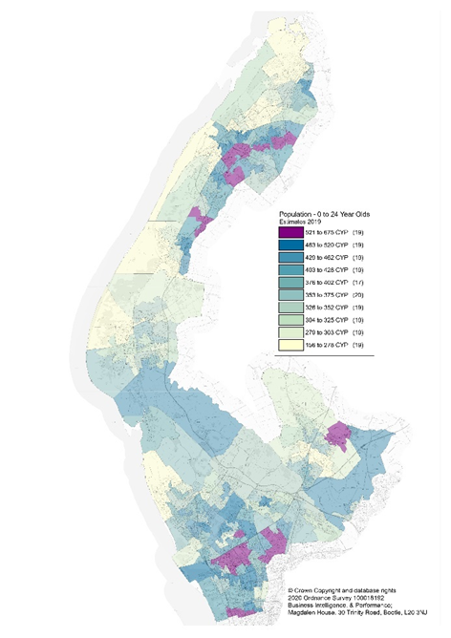
Sefton Council utilises a wide range of resources through its Business Intelligence and Performance Teams to plan the sufficiency of accommodation, informed by the Joint Strategic Needs Assessment (JSNA). Key highlights are included below.
0–24 and 0-17-Year-olds by Sefton Lower Super Output Area
The 2021 ONS mid-year population estimates state that there are 72,875 children and young people aged 0-24 reside in the Borough, which is 26% of the boroughs population, lower than the rates seen across the Liverpool City Region, the North-West and England (all with 30%).
The 2021 ONS mid-year population estimates state that there are 54,098 children and young people aged between 0 and 17 residing in Sefton, this makes up a fifth of the borough’s total population.
The children and young people population in Sefton has slightly more males (51%) than females (49%).
Approximately 94% of Sefton’s children and young people have an ethnicity deemed as White, with 92% White British higher than the comparator areas (LCR – 90%, the North-West – 81% and England - 73% respectively).
Population projections suggest that by 2043, there will be 72,157 children and young people aged 0-24 and approximately 53,041 0-17 years olds living Sefton, a slight reduction of 1% in contrast to the 1% increase in young people projected nationally.
0-19-Year-old Children Living in Relative Low-Income Families and Income Deprivation Affecting Children in Sefton (IDACI)
Since 2014/15 there has been an increase in the levels of children living in relative low-income families (CiLIF) within Sefton, comparative with that seen nationally, and it is estimated that there are approximately 10,655 children in low-income families with the highest density in the south of the Borough, equating to 18% of all 0-19-year-olds.
The average Income Deprivation Affecting Children Index (IDACI) score for Sefton 0.17, and overall, 56 of the LSOAs in Sefton have shown an increase in IDACI when comparing 2019 scores to those of 2015. 31 of the 189 LSOAs in Sefton fall within the top 10% of deprived areas in England, 5 of them in the top 1% of deprived areas national and a further 19 in the top 5% nationally. The patter matches the high density of (CiLIF) in the south of the Borough.
The Council declared a poverty emergency in March 2021. The Council was then presented with challenging findings of a review of child poverty in Sefton leading to the recommendation that the Council develop a Childhood Poverty Strategy which is designed to respond to the short, medium, and long-term challenges of tackling childhood poverty in Sefton
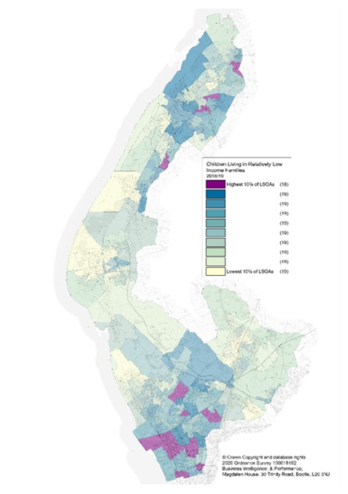
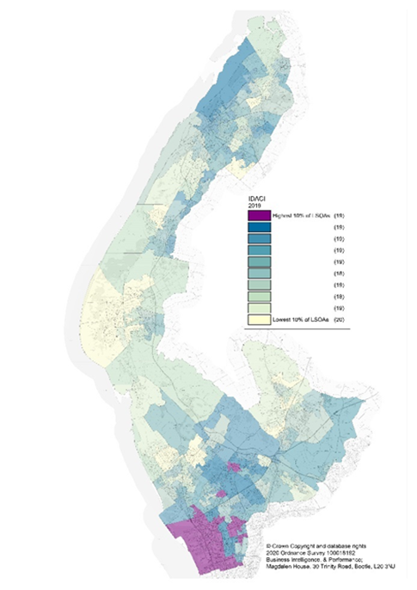
0 -19-Year-old Children Living in Relative Low-Income Families

Income Deprivation Affecting Children in Sefton (IDACI)

Youth Offending in Sefton
The table below shows the rates of first-time entrants aged 10-17 to the Criminal Justice system, showing an overall decline in the rate per 100,000 population since 2012, in-line with the picture for the Northwest and England. Latest figures show that the rate of children aged 10-17 cautioned or sentenced for an offence in Sefton is below the national average, however the percentage of young offenders in Sefton who re-offend is higher than the Northwest and statistical neighbour averages.
First Time Entrants to the Youth Justice System aged 10 - 17
(Rate per 100,000)
 | 2012 | 2013 | 2014 | 2015 | 2016 | 2017 | 2018 | 2019
Sefton | 585.80 | 423.60 | 365.20 | 284.60 | 226.00 | 250.60 | 224.60 | 172.80
Northwest | 558.60 | 432.50 | 398.90 | 342.80 | 296.40 | 261.40 | 245.60 | 200.90
Statistical Neighbours | 599.87 | 412.57 | 371.98 | 317.83 | 253.13 | 257.31 | 245.42 | 192.00
England | 557.10 | 449.10 | 413.50 | 374.70 | 331.80 | 297.70 | 240.90 | 208.00

Number of Children Cautioned or Sentenced 10 - 17
(Rate per 10,000)
 |  |  |  |  |  | 2018 | 2019 | 2020
Sefton |  |  |  |  |  | 47.90 | 44.60 | 32.10
Northwest |  |  |  |  |  | 48.50 | 41.90 | 32.20
Statistical Neighbours |  |  |  |  |  | 43.63 | 39.03 | 30.77
England |  |  |  |  |  | 51.30 | 40.70 | 34.90

Proportion of Young Offenders Who Re-offend (15 -17)
(%)
 | 2012 | 2013 | 2014 | 2015 | 2016 | 2017 | 2018 | 2019
Sefton | 48.15 | 45.80 | 42.76 | 40.00 | 46.25 | 54.26 | 52.83 | 35.44
Northwest | 43.65 | 45.39 | 45.20 | 43.92 | 41.54 | 40.34 | 37.67 | 32.05
Statistical Neighbours | 40.43 | 44.90 | 46.27 | 43.09 | 42.75 | 34.84 | 36.03 | 33.38
Looked After Children subject to a Conviction, Warning or Reprimand during the year
(%)
 | 2014 | 2015 | 2016 | 2017 | 2018 | 2019 | 2020 | 2021
Sefton | 9.30 | 4.00 | 5.00 | 4.00 | 5.00 | 4.00 | 0.00 | 0.00
Northwest | 6.00 | 5.00 | 4.00 | 4.00 | 5.00 | 3.00 | 2.00 | 2.00
Statistical Neighbours | 6.09 | 5.56 | 5.50 | 5.00 | 3.88 | 3.60 | 3.50 | 2.33
England | 5.60 | 5.00 | 5.00 | 4.00 | 4.00 | 3.00 | 3.00 | 2.00

There are currently 56 children (aged 11 to 18) with an open YOT case/plan. The average age of the cohort is 15 years old and 84% of them are aged 15 and above. 35 of these children have an open Children’s Social Care (32 children) or Early Help (3 children) plan, representing 62.5% of the full cohort of 56 children and 9 of these are Children Looked After.
Looking at the children of school age there are currently 36 children (aged 5 to 16) with an open YOT case/plan. The average age of the cohort is 14 years old and 33% of them are aged 15 and above. 19 of these children have an open Children’s Social Care plan, representing 52.7% of the full cohort of 36 children and 5 of these are Children Looked After.
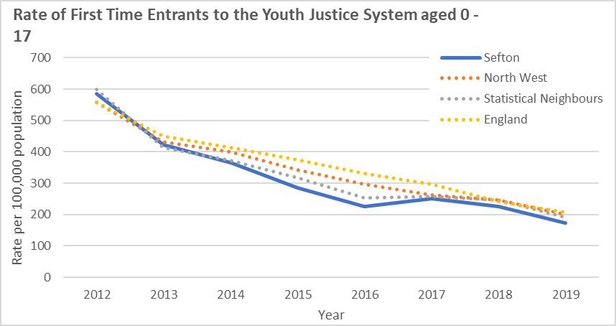

Looked after Children in Sefton
The table and graph below show the rate of Children Looked After per 10,000 under 18 population in Sefton over the previous eight full calendar years, which shows that Sefton has a considerably higher rate of Children Looked After per 10,000 under 18 population compared with the Northwest, statistical neighbour, and England averages. In January 2022 the rate of Children Looked After per 10,000 under 18 population in Sefton is 115 and the rate continues to increase on an upward trend.
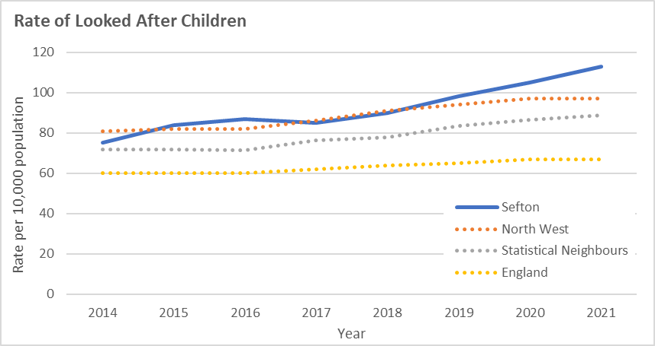
Children Looked After rate, per 10,000 Children aged under 18
(Rate per 10,000)
 | 2014 | 2015 | 2016 | 2017 | 2018 | 2019 | 2020 | 2021 | Jan 2022
Sefton | 75.00 | 84.00 | 87.00 | 85.00 | 90.00 | 98.00 | 105.00 | 113.00 | 115.00
Northwest | 81.00 | 82.00 | 82.00 | 86.00 | 91.00 | 94.00 | 97.00 | 97.00 | N/A
Statistical Neighbours | 71.90 | 71.90 | 71.30 | 76.40 | 77.90 | 83.60 | 86.30 | 88.70 | N/A
England | 60.00 | 60.00 | 60.00 | 62.00 | 64.00 | 65.00 | 67.00 | 67.00 | N/A

The following tables and graph show the number and percentage of Children Looked After in Sefton by Age Group to the end of January 2022. 10 – 15-year-olds make-up the highest proportion of Children Looked After in Sefton (35.7%).
Age Group - Count | 2018 | 2019 | 2020 | 2021 | Jan-22
Under 1 year | 19 | 31 | 23 | 28 | 28
1 to 4 years | 87 | 95 | 118 | 129 | 115
5 to 9 years | 116 | 122 | 146 | 145 | 154
10 to 15 years | 181 | 198 | 192 | 221 | 220
16 years and over | 77 | 81 | 87 | 90 | 99
Total Children | 480 | 527 | 566 | 613 | 616

Age Group - % | 2018 | 2019 | 2020 | 2021 | Jan-22
Under 1 year | 4.0 | 5.9 | 4.1 | 4.6 | 4.5
1 to 4 years | 18.1 | 18.0 | 20.8 | 21.0 | 18.7
5 to 9 years | 24.2 | 23.1 | 25.8 | 23.7 | 25.0
10 to 15 years | 37.7 | 37.6 | 33.9 | 36.1 | 35.7
16 years and over | 16.0 | 15.4 | 15.4 | 14.7 | 16.1

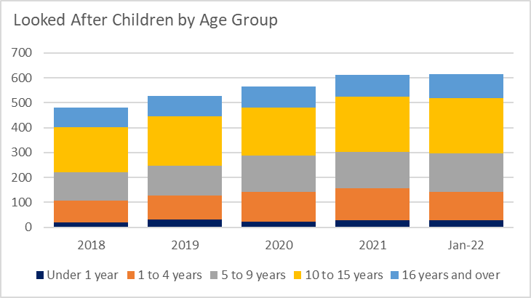
The following tables and graph show the rate of Children starting to be looked after in Sefton in comparison to the Northwest, statistical neighbour, and England average rates, the, number and percentage of Children admissions to care in Sefton (started to be looked after) by Age Group to the end of January 2022. The rate of Children starting to be looked after in Sefton has been consistently above the England average for the last four years.
Rate of Children starting to be Looked After
(Rate per 10,000)
 | 2018 | 2019 | 2020 | 2021
Sefton | 34.00 | 33.00 | 31.00 | 33.00
Northwest | 35.00 | 33.00 | 32.00 | 28.00
Statistical Neighbours | 28.90 | 31.20 | 31.10 | 27.40
England | 27.00 | 27.00 | 26.00 | 24.00

Age Group - Count | 2018 | 2019 | 2020 | 2021 | Jan-22
Under 1 year | 31 | 42 | 34 | 42 | 40
1 to 4 years | 41 | 39 | 45 | 41 | 29
5 to 9 years | 39 | 32 | 40 | 37 | 27
10 to 15 years | 65 | 49 | 35 | 40 | 38
16 years and over | 9 | 15 | 13 | 19 | 22
Total Children | 185 | 177 | 167 | 179 | 156
Age Group - % | 2018 | 2019 | 2020 | 2021 | Jan-22
Under 1 year | 16.8 | 23.7 | 20.4 | 23.5 | 25.6
1 to 4 years | 22.2 | 22.0 | 26.9 | 22.9 | 18.6
5 to 9 years | 21.1 | 18.1 | 24.0 | 20.7 | 17.3
10 to 15 years | 35.1 | 27.7 | 21.0 | 22.3 | 24.4
16 years and over | 4.9 | 8.5 | 7.8 | 10.6 | 14.1

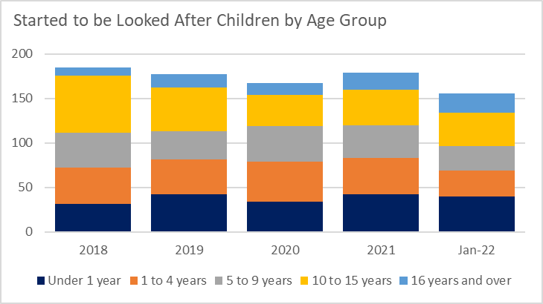

The following tables and graph show the rate of Children discharged from care in Sefton in comparison to the Northwest, statistical neighbour, and England average rates, the, number and percentage of Children admissions to care in Sefton (ceased to be looked after) by Age Group to the end of January 2022. The rate of Children ceasing to be looked after in Sefton has been broadly in-line with the England average for the last four years.
Rate of Children ceasing to be Looked After
(Rate per 10,000)
 | 2018 | 2019 | 2020 | 2021
Sefton | 30.00 | 25.00 | 24.00 | 25.00
Northwest | 30.00 | 30.00 | 29.00 | 28.00
Statistical Neighbours | 27.50 | 25.80 | 28.40 | 25.20
England | 25.00 | 25.00 | 25.00 | 23.00

Age Group - Count | 2018 | 2019 | 2020 | 2021 | Jan-22
Under 1 year | 8 | 7 | 8 | 7 | 10
1 to 4 years | 31 | 29 | 37 | 34 | 42
5 to 9 years | 22 | 24 | 17 | 21 | 18
10 to 15 years | 37 | 22 | 17 | 14 | 26
16 years and over | 66 | 51 | 50 | 57 | 49
Total Children | 164 | 133 | 129 | 133 | 145
Age Group - % | 2018 | 2019 | 2020 | 2021 | Jan-22
Under 1 year | 4.9 | 5.3 | 6.2 | 5.3 | 6.9
1 to 4 years | 18.9 | 21.8 | 28.7 | 25.6 | 29.0
5 to 9 years | 13.4 | 18.0 | 13.2 | 15.8 | 12.4
10 to 15 years | 22.6 | 16.5 | 13.2 | 10.5 | 17.9
16 years and over | 40.2 | 38.3 | 38.8 | 42.9 | 33.8

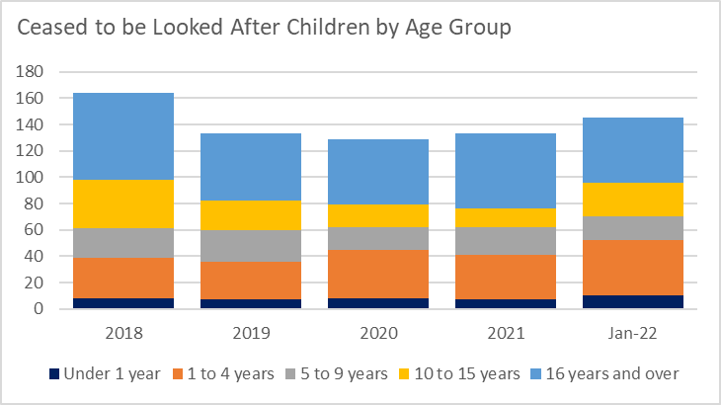
The following table shows the numbers and reason for Children discharged from care in Sefton (ceased to be looked after) by Age Group to the end of January 2022.
Reason | 2018 | 2019 | 2020 | 2021 | To Jan 22
E11 - Adopted, application unopposed | 8 | 14 | 8 | 7 | 12
E12 - Adopted, consent dispensed with | 5 | 8 | 8 | 5 | 6
E13 - Left care to live with parents, relatives, or other person with no parental responsibility-this code should be used if the child left care to live with parents, relatives, or another person, but this person did not have parental responsibility | 11 | 1 | 3 | 11 | 5
E15 - Age assessment determined child is aged 18 or over and E5, E6 and E7 do not apply e.g., UASC whose age has been disputed | 2 | 0 | 0 | 4 | 0
E41 - Child Arrangement order granted | 4 | 2 | 3 | 3 | 12
E43 - Special guardianship order made to former foster carers | 11 | 11 | 7 | 0 | 0
E44 - Special guardianship order made to carers other than former foster carers | 8 | 2 | 9 | 3 | 0
E45 - Special Guardianship Order made to former foster carers, who were a relative or friend. | N/A | N/A | N/A | 9 | 26
E46 - Special Guardianship Order made to former foster carers, other than relative or friend. | N/A | N/A | N/A | 2 | 3
E47 - Special Guardianship Order made to carers other than former foster carers, who were a relative or friend. | N/A | N/A | N/A | 5 | 0
E4A - Return home to live with parents, relatives, or other person with parental responsibility as part of the care planning process (not under a Residence Order or Special Guardianship Order) | 22 | 26 | 20 | 20 | 20
E4B - Return home to live with parents, relatives, or other person with parental responsibility which was not part of the current care planning process (not under a Residence Order or Special Guardianship Order) | 7 | 3 | 7 | 5 | 8
E5 - Moved into independent living - supported accommodation | 10 | 5 | 23 | 15 | 5
E6 - Moved into independent living - no formalised advice | 5 | 1 | 3 | 2 | 4
E7 - Transferred to adult social services care | 6 | 4 | 0 | 3
E8 - Period of being looked after - ceased for any other reason | 65 | 49 | 37 | 26 | 24
E3 - Care taken over by another LA | 0 | 6 | 1 | 4 | 3
E9 - Sentenced to custody | 0 | 1 | 0 | 0
E17- Age 18 (or over) and remained with current carers (incl. under staying put arrangements) | N/A | N/A | N/A | 10 | 17

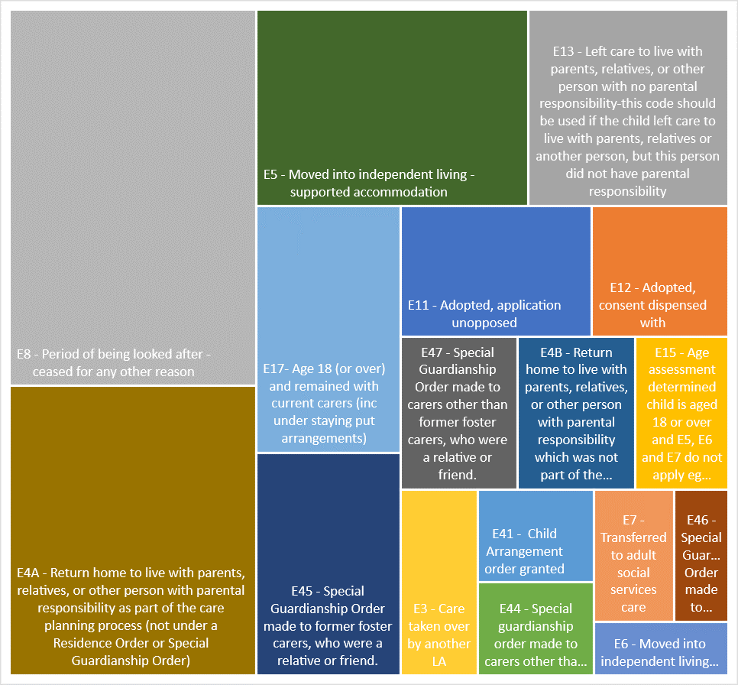
The following table shows the percentage placement stability for Children Looked After in Sefton, which includes those living in the same placement for at least 2 years or are placed for adoption and their adoption and their adoptive placement together with their previous placement, lasting for at least 2 years.
Placement Stability
(%)
 | 2018 | 2019 | 2020 | 2021
Sefton | 69.00 | 72.00 | 71.00 | 77.00
Northwest | 70.00 | 69.00 | 68.00 | 71.00
Statistical Neighbours | 71.30 | 69.60 | 69.00 | 70.80
England | 69.00 | 68.00 | 68.00 | 70.00

Needs Projection to 2025
On the 18th of February 2022 there were 619 Children Looked After in Sefton, an increase of over 42% from 436 in February 2017, and using a linear trendline this number is projected to increase further by approximately 24% to 770 Children over the next three years to February 2025.
 | Mar-22 | Mar-25
LAC Number Projection | 619 | 770
 | £000 | £000
Current Cost | 30,451 | 30,451
Cost Projection - increase in LAC | 0 | 7,429
Cost Projection - uplift | 0 | 3,927
Total Cost | 30,451 | 41,807
* Total Cost excludes Cherry Road, Adoption Allowances, Support Packages etc.

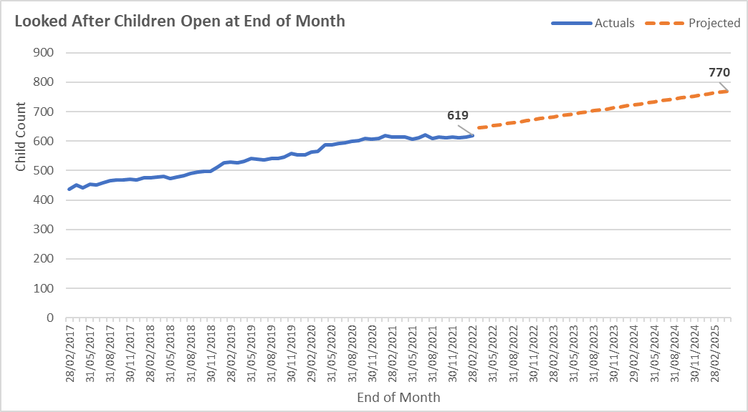

Sefton accommodation profile
The Sufficiency Duty requires Sefton Council to have a range of appropriate quality accommodation options for children in care and care leavers. The type of accommodation where a child is placed will depend on their assessed needs.
Continuum of accommodation
The Table below shows the continuum of accommodation types available by age.
The continuum of accommodation types available by age. | Totals
Fostering In house – 0 to 18 | 247
Fostering IFP - 0-18 | 150
Staying Put – 16 to 21 | 22
Semi Independent Accommodation (SaILs) | 31
Local Solutions | 20
Residential Children’s Homes – 0 to 18 | 70
Emergency Safety Accommodation - 16 to 21 | N/A

Accommodation Types
The Table below provides typical features and commissioning arrangement by placement type along with a snapshot of placements as of December 2021.
Type of Provision | No Off Framework | No On Framework | Direct
Residential | 11 | 60 | 0
IFP | 5 | 135 | 1
SaILs | 30 | 3 | 0
SSL | 0 | 0 | 22

Accommodation and Support Spend
The Table below provides a breakdown of current spend re:
Setting Type
 | P10 Current Expenditure |  | Forecast 21/22 Expenditure
 | £ |  | £
Residential | 12,119,924 |  | 14,000,100
In House Fostering | 3,175,235 |  | 3,863,500
Independent Fostering | 4,745,315 |  | 5,690,000
Supported Living incl SAILS and Supported Lodgings | 1,733,306 |  | 1,935,500
Special Guardianship Orders | 1,508,673 |  | 1,795,500
Child Arrangement Orders | 251,222 |  | 298,000
Adoption Allowances | 470,828 |  | 571,100
Source: P10 Budget Monitoring report
Average Costs
 | £
Residential | 4,528
In House Fostering | 241
Independent Fostering | 798
Supported Living incl SAILS and Supported Lodgings | 1,062

Our Overarching Approach and Principles to deliver this Strategy
The needs assessment and projection of a further increase in our children looked after by 2025 sharpens further our ambition and intention to respond proactively and with conviction.
Our commissioning approach will rethink services and the way we work with families. We will invest in the right support at the right time, enhancing early help and prevention so that fewer children come into care. We will encourage participation by engaging providers, children, young people and their families to support us to design services and influence the way in which they are delivered wherever possible.
We will develop provision with key providers to ensure a range of local specialist support and choice. We will focus on ensuring that the local market is developed over time so children and young people who remain in our care are able to continue to live in a family setting with the right support within or close to the Borough. As Corporate Parents we will provide scrutiny and seek assurance that the Strategy and the actions are owned and implemented by all professionals and partner organisations working with children, young people, their parents and carers to secure the best outcomes for our children.
We will take a relationship-based approach to ensuring that we work with our stakeholders to offer the best quality services with excellent outcomes for children and young people. To enable this we will be honest, transparent and always keep the child or young person at the centre of all considerations. Wherever possible our communication to stakeholders will be timely, clear and inclusive.
We understand that in Sefton all our providers want to work with us to achieve the best outcomes for our children. We will take a facilitative rather than punitive approach to problem solving when things go wrong. This does not mean that we will not be brave and swift in challenge when our children are unsafe or not getting the best possible service.
Our commissioning decisions and recommendations will be wherever possible outcome based. Effective delivery will be assured through robust monitoring, recording and evaluation. Contract compliance and quality will be monitored through a scheduled programme of quality assurance visits which will be carried out alongside service and will account for the lived experience of the child or young person.
Commissioning activity and performance will be managed proactively deploying a programme approach to the market which will give assurance of grip and pace during this exciting period of improvement and transformation.
The core principles for our approach are:

Integrating provision
Sefton is actively committed to preventative and early intervention services for all ages through open access and early help services. Halting a problem developing early on is better for children, for young people and for their families. Sefton will integrate the early help services with clearly defined thresholds in relation to a universal and targeted offer, to enable it to focus more on those families which will most benefit from early support.
Sefton will support and maintain a diversity of early help services to better meet the needs of children in care including through the provision of preventative and early help intervention services. This will reduce the need for care proceedings and therefore the need for statutory accommodation-based support.

Listening to our children
Sefton values the voice of the child and seeks to listen in a range of ways to children and young people and through a range of forums. The continuation of this work is at the heart of our Sufficiency Strategy.

Placement Stability and Sufficiency
Placement Stability is improving in Sefton and our aim is for this to continue coupled with our ambition to increase placement choice. The criteria which must be used wherever possible include:
- Allowing the child to live near his/her home wherever it is reasonably practical
- Not disrupting the child’s education or training
- Enabling the child and looked after sibling to live together
- Meeting the needs of disabled children
- Proving accommodation within Sefton’s local authority area unless that is not reasonably practicable or in the interests of the child
- Ensure suitable adaptations where a child has a disability
- Adherence to changing policy and government guidance

Preventing Homelessness
Sefton Council and our partners are committed to preventing homelessness and as a Corporate Parent we will ensure that children in our care are prioritised. The recently refreshed Housing Strategy reinforces this commitment and reflects the priorities in relation to suitable and good quality housing provision for our young people leaving care and the recognition that foster carers when seeking to foster larger sibling families will be accommodated. .

Working in Partnership
We are committed to sustaining stable relationships between internal and external stakeholders and to using open and transparent processes that build confident partnerships with our statutory partners and the voluntary and community faith sector in Sefton

Dynamic and brave commissioning
We will continue to develop our Strategic Commissioning Model and approach not just to retain existing services or commission new ones but, where necessary, to decommission services which are inefficient, ineffective, inequitable or unsustainable. We will be brave in our thinking and will push the boundaries to achieve improved outcomes for our children and young people

Best Value
We will develop a value model of accommodation and support with providers as experts in delivery, taking account of value for money in all decisions and providing information to enable robust performance management both in relation to quality and efficiency.

Our Key Challenges
The needs assessment and profiling of current service provision identifies a number of key challenges:
- There are too many looked after children in the care of the Local Authority. Numbers are forecast to continue to increase
- There is a need to ensure that the Local Authority has provision which enables it to manage demand and that preventative provision and early help is strengthened and consolidated to minimise the number of children coming into care. For some children, for whom the right decision has been to become looked after, there should be sufficient timely access to appropriate specialist support
- The number of those children in care placed out of borough is too high, closing gaps in the provision of sufficient local placement accommodation, preferably in a family setting, is required so children and young people in care and care leavers are able to continue to live within or close to the Borough
- There is a need to work with key providers of specialist provision to help us to meet a range of needs and sufficiency of placement provision. More needs to be done to ensure the efficient and effective operation of our local market. Delivering much better value in terms of quality, price, unit costs and outcomes is essential across all provision

Our response
In response to the challenges we face, we are committed to four clear intentions which will inform our commissioning:
- For those children and young people on the edge of care, we will ensure that they are supported to stay with their parents or extended family and only come into care where it is absolutely necessary and justified in the best interests of the child or young person, and that all support options and strategies have been exhausted.
- For young children who come into care we will work to return to their birth or extended families, as a best outcome for them, when it is safe to do so. Where it is not, we will seek permanency for them through adoption or special guardianship orders wherever possible.
- For children who remain in our care we will ensure that we have good quality placements in a family setting or suitable residential provision in or close to Sefton
- For young people leaving care we will ensure that we have sufficient accommodation locally to meet their needs including support to enable smooth transition to independent living
We intend to facilitate a reduction in the number of children and young people looked after in Sefton by investing in the right support at the right time for children and families across early help and on the edge of care; children’s social care and education settings to develop better, more affordable placement choices. It is our intention to develop a range of preventative and support services/ interventions.
We will develop enhanced ‘Edge of Care’ interventions within Early Help Services to support children and families where there is an immediate risk of family breakdown or to respond to families in crisis. This will ensure that the opportunity to intervene earlier when problems begin to emerge is enhanced by a robust continuum of evidence- based practice across the children’s workforce.
The diagram below captures our future approach:
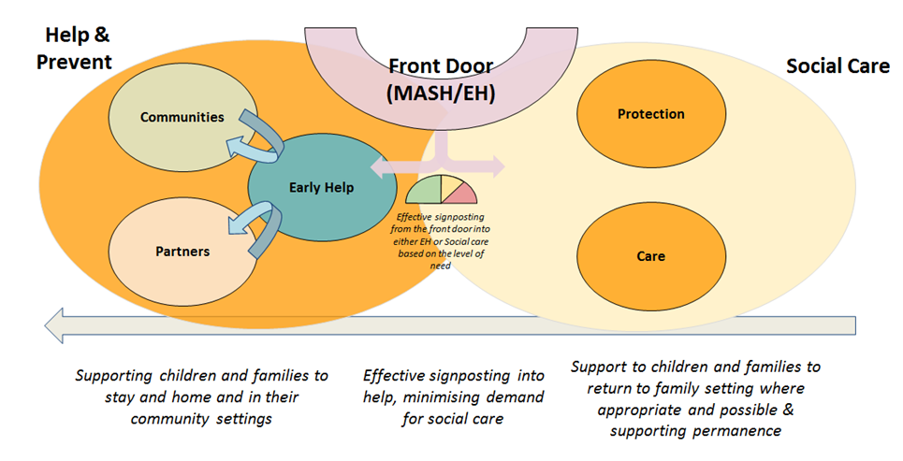
We will establish an ‘Edge of Care’ Model – by mobilising a dedicated natural team of practitioners which will work across traditional organisational boundaries offering a range of services to support children to remain living safely with their immediate or extended families, they will be given the best chance to thrive without long-term reliance on services.
We will commission Multi-Systemic Therapy (MST) – an intensive programme that works within the whole ecology of a young person including parents, family, the community and school at the same time in a solution-focused, strengths-based approach to empower the family to take responsibility for solving problems. In the longer term this strategy will also push demand for placements down from costly high tier services to less expensive early interventions.
We will further establish Family Group Conferencing (FGC) as our child-centred, family-led decision making and planning process which will develop existing strengths to build safety for children. Targeting services at children and young people at an earlier stage of their journey is likely to reduce the number of children subject to a child protection plan and consequently reduce the numbers that escalate to PLO care proceedings and ultimately entering care.
We will continue the work to consider and formally assess young people in terms of the viability of them returning to the care of their birth/extended families. We will ensure that support is in place to give the best chance of successful and permanent reunification.
We will continue to support permanency through Adoption and special guardianship.
Looked After Children are a particularly vulnerable group and are at high risk of social exclusion, health inequalities, inequalities in educational attainment and wider negative outcomes. We acknowledge that it is critical to ensure we place LAC in the most appropriate placement available and that we have a market available to meet those needs.
It is our intention that wherever possible, children and young people should be looked after in Sefton in a family setting, placed with foster carers and in-house foster carers where these are available. In-house foster carers are able to offer placements at a lower cost than Independent Foster Agency placements. Reducing the overall costs of providing service to children and young people in care enables us to invest more in services to children and young people who are on the edge of care, and in preventative services.
We will increase the number of Foster Carers in the local authority, but importantly, increasing this supply of capacity sufficiently to ensure more placement choice when matching children with fostering families. We must improve our offer to Foster Carers in order to compete with external fostering agencies. We need to recruit and remunerate specialist foster care placements including respite for children with disabilities, mother and baby and CE placements. The use of the digital platform has proved to be a successful tool for recruitment of Foster Carers, this needs to be further developed. We will work closely with colleagues in Fostering and Finance to further our in house ambition.
Independent Foster Agencies will continue to be an important provider in ensuring the sufficiency of accommodation for looked after children. Whilst in overall terms our intention is to reduce our current reliance on them, there will be a focus on working with them develop a sufficient local provision and to secure better value in terms of quality, price and outcomes. IFA’s will continue to provide the Council with an important viable alternative to out of authority residential provision.
For some children and young people, a residential placement will be the right option. We will continue to ensure sufficiency of residential placement whilst looking to reduce out of borough residential placements gradually over time so as not to remove a child from settled and successful placement. We will work with providers through our Market Position Statement to develop appropriate services for future need.
The development of a combined Local Pseudo Dynamic Purchasing System (PDPS) based on a strategic partnership approach based on the child’s journey and with residential providers and independent fostering agencies at its core is a priority. Such an approach will inform a local market offer which will focus on outcomes for children, be cost effective and enable a collective provider led approach to supporting the step down from residential to fostering, thereby mitigating the risk of drift. The PDPS has been approved by Cabinet in February 2022 and contracts will be awarded in January 2023.
A PDPS will enable a local commissioning grip on quality and cost, a strong line of sight to the child and facilitate the shaping of a commissioning relationship with providers based on the improvement of outcomes for the child and value for money. It will also enable the introduction of social value with a focus on local provision for local children. As identified in the National Procurement Strategy 2015 building strong relationships with social care providers is an important facet of good social care procurement, not least because it is a crucial factor in fostering innovation.
The core commissioning outcomes the Local Strategic Partnership will achieve are:
- Local Homes for the local Children and Young People of Sefton
- Line of sight strengthened to safeguard the most vulnerable Children
- Effective market management and improvement of the relationship with providers to build a more collaborative approach and subsequent shaping of new and alternative models of support
- Improve quality through the consistent application of local quality assurance standards
- Deliver cost reductions and a value model of accommodation and support
- Increase local placement choice
- Reduce the risk of unregulated placements
- Collaborative development of services to care for children at a lower level of need following intervention with a commitment to supporting step down, shape the growth of semi-independent residential placements
- Block contracting as a means of securing best value
- Joint commissioning with the CCG’s and address current gaps in relation to clinical support
- Social Value with providers committed to promoting local skills and employment, sustainable and local business growth, healthier, safer and resilient communities, promoting and enabling innovation, fair and ethical employment practice
The PDPS will shape the local market offer according to changing assessed need and local strategic priorities with a clear Sefton branding growing local business and providing stability for the most vulnerable Children and Young People.
We will develop strategic partnerships with independent providers to ensure that Looked After Children can be cared for in Sefton to mitigate against high risk of social exclusion, health inequalities, inequalities in educational attainment and wider negative outcomes.
We will examine the feasibility of re-launching our internal Residential Homes and consider the development of new accommodation and support models which focus on safety, stabilisation and assessment and outreach for our most complex children and their preparation for adulthood.

Preparation for Adulthood
As corporate parents we understand that our aspirations for young people leaving our care continues well into their adulthood. Transition pathways will be strengthened enabling continuity of support based on life course principles and outcomes. We will engage with Adult Social Care and will work across the system as a natural leader to develop the resilience of young people and the commissioned market offer.

Voice of the Child
Strategic Commissioning will hold young people at the heart of inspecting services delivered to children and young people through the development of a ‘Young Inspectors’ scheme which will be established to make sure services are meeting quality standards and that the voices of children and young people as listened to and acted upon.
The balance of the listening and action is on an individual child level. Our next phase is to ensure that views, opinions and feedback are more systematically collected, that we capture intelligence that can be used to influence the commissioning of services, and that we encourage participation of children and young people in their design and continuous improvement.
The intention is that we redistribute power within our social care system by connecting life experiences to strategy. We will co-produce and co-design strategy and services with children and young people. We will work to gain the children and young people’s trust and take the time to create safe and stimulating spaces to enable their voices to be heard.
The approach we will take to co-producing with our stakeholders is two-fold:
- Participation in service design/ redesign
- Hearing their voice in the everyday experience of the service
For all future commissioning it is imperative to work with all stakeholders throughout the design process in order to develop the right services in the right way.
What we will do throughout the life of the service is gather qualitative and quantitative data around our stakeholder’s experiences using this as a tool for continuous improvement. We will use this data to clearly define any problems or issues that emerge and will seek solutions. The intelligence we gather will be systematically used to inform future commissioning.
Effective commissioning is critical to successful delivery of the sufficiency strategy and as part of that the participation and engagement of children and young people in co-production, design and the continuous improvement of value for money services

Conclusion
This Strategy outlines the current challenges faced in meeting our sufficiency duty in Sefton. Strategic priorities have been identified and actions and interventions outlined, that when implemented will mean we are better placed to meet our Sufficiency Challenge and deliver a financially sustainable Children’s Services. The outcome of the Strategy will be to safely and appropriately reduce the number of young people requiring care by the local authority.
Our intention is to strengthen and consolidate the early help offer and develop a range of preventative support services, some of which may require investment to facilitate the reduction in numbers and deliver the necessary cost reductions and improved outcomes:
- Supporting children and young people on the ‘edge of care’ to stay at home
- Returning children to their birth/extended families when safe to do so
- Placement commissioning and development
- Support around the placement to meet the individual needs of the child/young person and carer
We will establish key measures which will help us to understand whether we are making a difference amongst which will be:
- The number and rate of Looked After Children
- Comparison with statistical neighbours and England average (rate per 10,000)
- Reduction in overall placements costs
- Reduction of placement disruption to at or below national average.
- Increase in placement stability and decrease placement disruption
- Increased permanency – adoption and special guardianship
- A changed composition of placements over time to increase the share of in-house foster care provision, have sufficient independent foster agencies and residential placement provision in the local area.
Throughout the life of this Strategy we will continue to work with our children in care, care leavers and key partners to develop our plans and priorities. We believe it is important that this Strategy remains a ‘live’ document. The Strategy will be reviewed annually to ensure that it remains as relevant in 2025 as it is now.
The delivery of the Strategy will be underpinned by the dynamic Strategic Commissioning and Operational Delivery Plan and will be reported to the system Executive Commissioning Group, the Senior CCG Leadership Team and Integrated Care partnership, the Corporate parenting Board and the Health and Well Being Board .
The Sufficiency Strategy will take time to show results. We must be able to ensure that demand levels are met through the creative use of existing provision. We need to assess the suitability of current provision through robust quality assurance and set the required standards of future provision. Establishing excellent working relationships with providers and partners in all sectors will be critical to increase trust, transparency and ownership across the system. The development of a self- improving system, encouraging system leaders will be key within this context to ensure effective implementation and sustainability.

